Motion Fast 82KW Charger Fuse Failure SOP

- Fault Name:Fuse failure
- Fault code:without
- Fault phenomenon:Unable to charge, the screen reports the fault
- Cause of failure:Fuse failure
- Applicable models:Motion Fast 82kW
- Troubleshooting steps:
procedure | Contents | Example (picture or reference file)
Step1 | Disconnect the AC contactor of DC pile, and measure the on-off condition of the fuse by using the buzzer gear of multimeter.  If there is a beeping sound, the fuse is normal.  If there is no beeping sound, it means that the fuse is damaged, and execute Step2; | 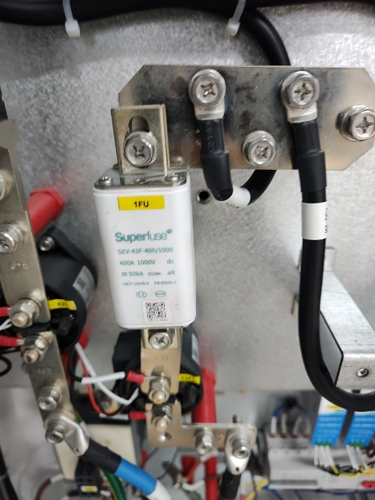
Step2 | Use a 13MM wrench to remove the fuse; | 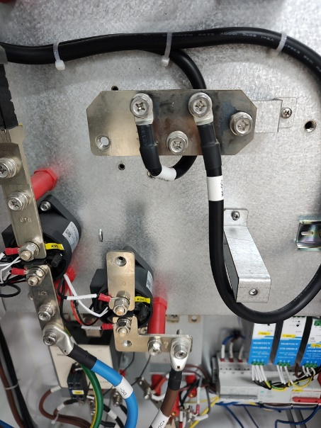
Step3 | After replacing the new fuse, repeat Step1 to measure whether the new fuse is conductive.  If it is turned on, carry out a charging test again; If it is still not connected, please contact the local after-sales service team to handle it.  If charging is normal, the device will return to normal;  If the charging is still abnormal, please contact the local after-sales service team. | 