Offline SOP for AC Charger Platform

- Fault Name:without
- Fault code:without
- Fault phenomenon:After the charging pile runs for a period of time, it is displayed offline in the monitoring platform
- Cause of failure:
- 4G traffic card traffic runs out or expires
- Unstable WiFi connection
- Unstable network cable connection
- Unstable router connection
- Communication module connection loose
- Applicable models:
- Atom AC Charger
- ACE AC Charger
- Robot AC Charger
- Troubleshooting steps:
procedure | Contents | Example (picture or reference file)
Step1 | If the AC pile is ACE AC Charger and Robot series, refer only to Step2;  If the pile is of the Atom AC charger series, refer to Step2-Step7;
Step2 | Confirm whether the pile uses 4G communication, WiFi communication, or Ethernet communication.  If the pile uses 4G communication, check whether the traffic card traffic is used up or has expired, and if so, replace the traffic card;  If the pile uses WiFi communication, check whether the WiFi signal is stable; If so, try to strengthen the WiFi signal;  If the pile uses Ethernet communication, check whether the network cable is tightly connected and damaged; If so, replace the network cable; If not, check the router networking status;  If there is no problem in any of the above checks, refer to step3;
Step3 | Disconnect the mains to completely disconnect the AC pile. After completion, refer to Step4;
Step4 | Disassemble the housing of the AC pile and check whether there is any poor contact between the communication board and the control board.  If present, refer to Step5;  If not present, refer to Step6; | 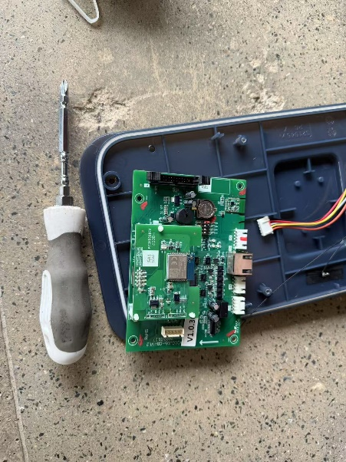
Step5 | Remove the communication board and the control board, take out the original plastic bracket, replace it with a metal bracket, confirm that the two are tightly connected, install it back to the AC pile and cover the AC pile shell.  Close the mains opening to restore power to the AC pile. Wait 3-5 minutes to observe if the AC pile resumes communication with the monitoring platform (i.e. the operating status shows "online").  If restored, the problem is resolved.  If it is still not restored, refer to Step6; | 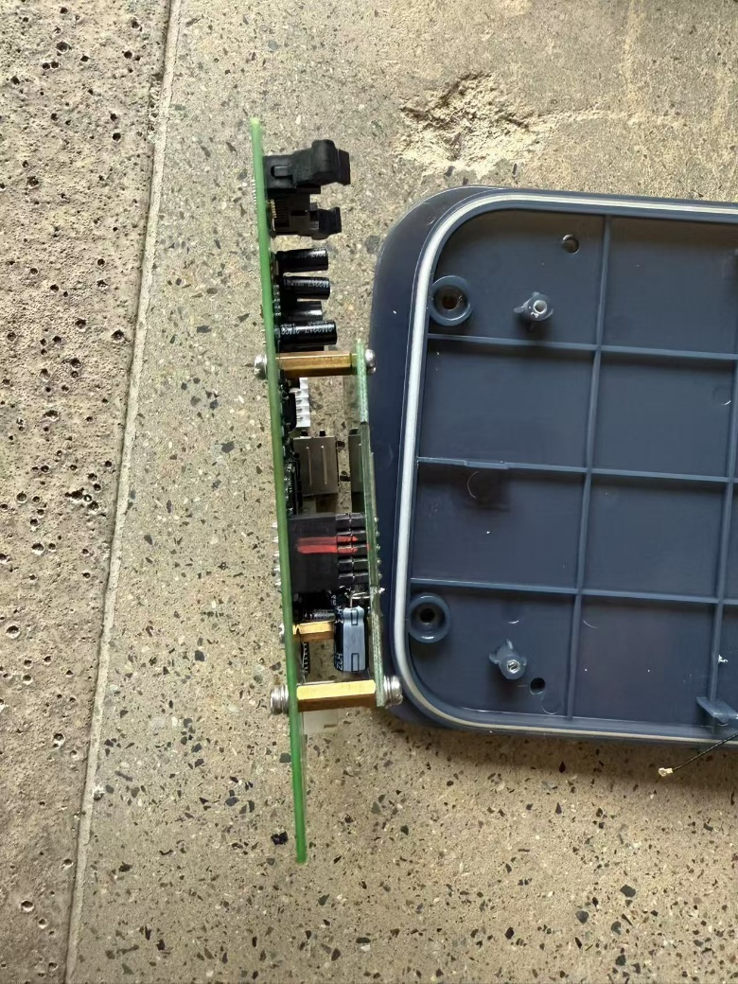
Step6 | None of the above steps solved the problem, please contact the local after-sales service team to handle it.

Typography requirements:
- The basic typography style is as above;
- The black font is a fixed title and cannot be changed; The green font is the part of adding content;

Text requirements:
- File Title:
"Product Line Abbreviation""Number" _ "Fault Name" SOP
Product line: INV inverter, BAT battery, BES energy storage cabinet, EVC charging pile;
Number: Each product line is numbered independently, starting from 0001;
Fault Name: Description as concise and refined as possible;

- Font: Standard Song (Chinese, English)
- Font size:
- Title: Two, bold, centered
- Text title: No. 5, bold
- Text: No. 5, not in bold
- Color: Black
- Line and paragraph spacing: 1.5 times
- Paragraph description (phenomenon, cause, treatment content): the first line is indented by 2 times

Image requirements:
- Format: JPG, PNG
- Size: It is recommended that within 300kb, the picture should not be too large and should not exceed 1M (if it exceeds, the picture size should be reduced)
- Video: If you have a video, you can take several pictures containing key information in a row

Attachment Requirements:
- Format: Uniform conversion to PDF
- Document title: uniformly named as "Product Line Abbreviation""Number" _Attachment Document Title_Serial Number (if there are multiple documents) "

