Offline SOP for Atom Charger

- Fault Name:Offline failure
- Fault code:F00001
- Fault phenomenon:Devices offline on platform
- Cause of failure:Communication module bracket defect
- Applicable models:Atom (WIFI version)
- Troubleshooting steps:
procedure | Contents | Example (picture or reference file)
Step1 | Disassembling the charging pile panel and pulling out the pins of the communication module; | 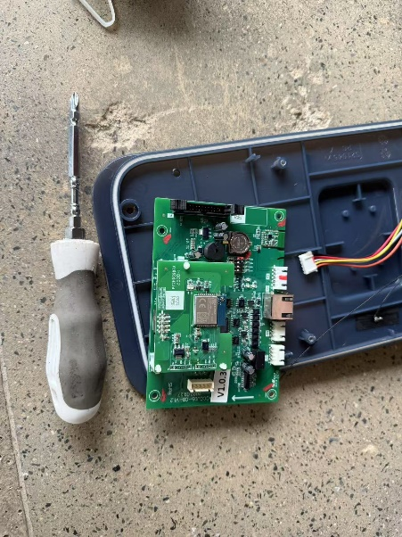
Step2 | Replace the three metal screw brackets that hold the communication module, reinstall them, and confirm that the pin contacts are in place; | 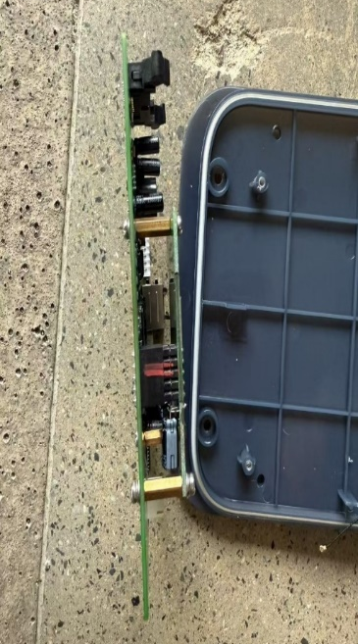
Step3 | Install all remaining accessories. | 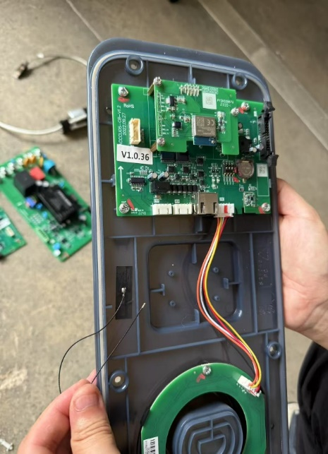
Step4 | Power up again and check again whether the registered monitoring platform is online;  (The registered monitoring platform may be the monitoring platform owned by the customer or the official monitoring platform of Livoltek)  If online again, the offline fault is resolved;  If you are still offline, please contact your local after-sales team for support. | 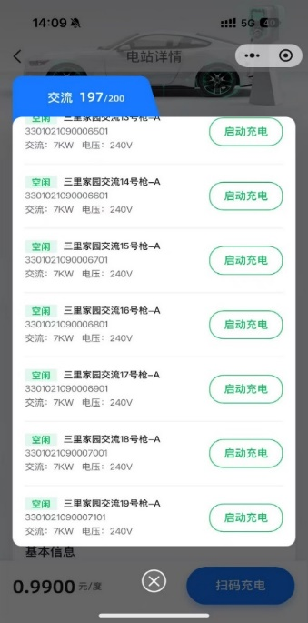  App Interface from Operator Part

