SOP for Communication Failure Between TCU and CCU

- Fault Name:Communication failure between TCU and CCU
- Fault code:1
- Fault phenomenon:The screen gun head interface turns gray and there is an error prompt. Click in to report the communication failure between TCU and CCU.
- Cause of failure:
- The communication line between TCU and CCU is virtually connected and damaged;
- Port device loose
- Applicable models:Motion Fast 60-120kW
- Troubleshooting steps:
procedure | Contents | Example (picture or reference file)
Step1 | Priority is given to eliminating false positives or sporadic errors.  You can try to turn off the power of the whole charging pile. Pay attention to turning off the main circuit breaker and the auxiliary circuit breaker at the same time, and then turn it on again to observe whether the communication is restored.  If the error continues to be reported, turn off the circuit breaker and jump to Step2;
Step2 | Check the port and line sequence.  First check the ports. The communication ports on CCU and TCU are B3 (Can-L) & B4 (Can-H), and the communication ports on TCU are D1 (B4) & D2 (B3). Please confirm that the communication line is connected to this port.  Check whether the line sequence is correct, and if not, power it up again after adjustment to check whether the fault is eliminated;  If correct or the fault still exists after adjustment,Turn off the circuit breaker and jump to Step3;
Step3 | Check the communication wire wiring.  First, check whether the screws at the port are tightly tightened, and then observe whether the front end of the tubular terminal is tightly pressed, whether there is any bending damage, and whether the wire is pushed to the outlet position.  After confirming that the above problems have been improved, power back on to see if the fault has been eliminated.  If the fault persists,After turning off the circuit breakerJump to Step4. | 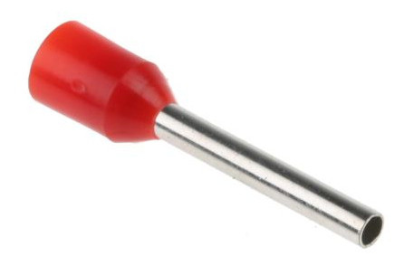
Step4 | Check whether each of the two communication lines is conductive.  Use the diode file of the multimeter to measure whether the two ends of the wire are conductive. If there is a beep, it is conductive.  If turned on, jump to Step5;  If it is not conductive, replace the communication line and power it back on to see if the fault is eliminated. If the fault still exists, jump to Step5;
Step5 | If none of the above steps can solve the problem, please contact your local after-sales service team.

