Treatment SOP for Abnormal LCD Display

- Fault Name:LCD display abnormal
- Fault code:/
- Fault phenomenon:
- Wrong screen size
- Display blurred screen
- Display Black Screen
- Cause of failure:
- The screen is set incorrectly
- Loose wiring
- Screen failure
- Applicable models:MotionFast 60~120kW
- Troubleshooting steps:
procedure | Contents | Example (picture or reference file)
Step 1 | If the Screen display size is wrong, and the coordinate offset is not large, and the Screen can still be operated, enter "Maintenance"-"Function Debug", and click the "Screen Calibration" button to calibrate the Screen.  If the coordinate offset is large and cannot be operated, please contact the local after-sales service team. | 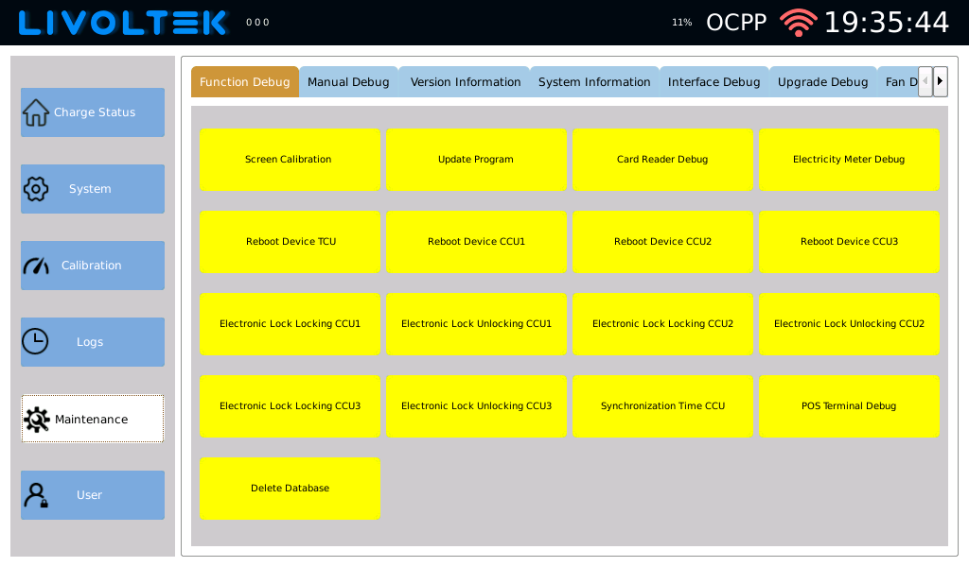
Step2 | If the screen is blurred, try replugging the adapter cable. If it doesn't return to normal,Please contact your local after-sales service team | 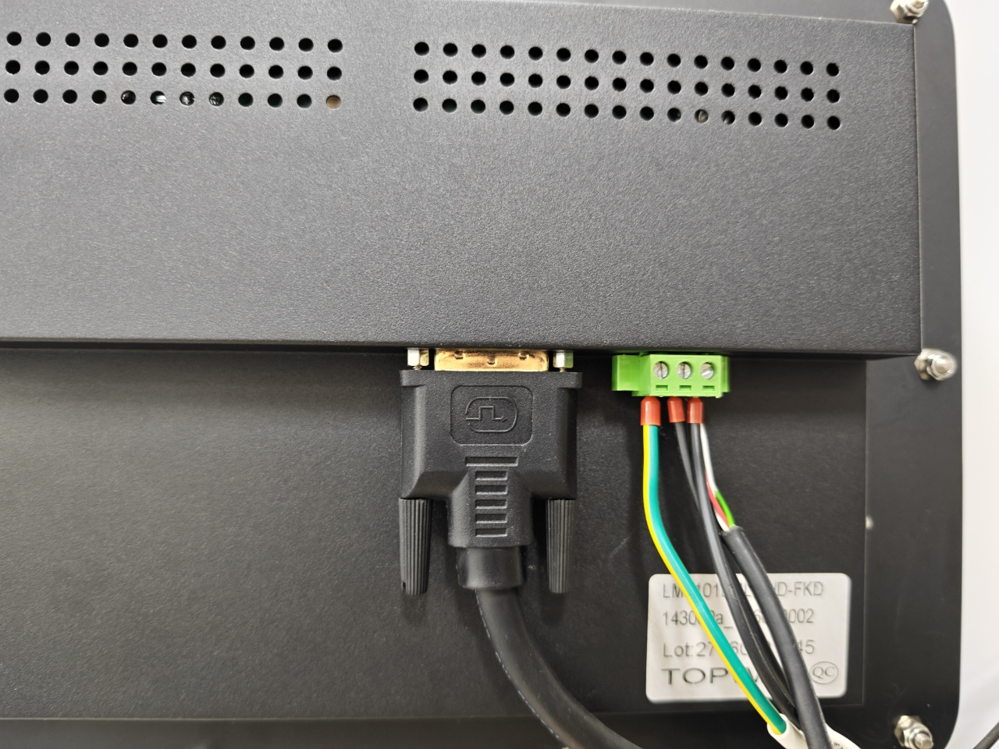
Step3 | If the screen does not display content, try replugging and unplugging the power cord and see if the marking on the power cord number tube at the screen interface matches the TCU terminal line sequence.  If there is no match, please make a match, and after adjustment, check whether the screen is displayed normally.  If it still can't be displayed normally or has been matched, check whether the wire screws are tightened, and then observe whether the front end of the tubular terminal is tightly pressed, whether there is any bending damage, and whether the wire is pushed to the outlet position.  After making the corresponding adjustments, if the screen cannot return to normal,Please contact the local after-sales service team to handle it. | 