Treatment SOP for Grounding Fault of AC Charger

- Fault Name:Grounding fault
- malfunctionCode:F2 00000001
- Fault phenomenon:The monitoring platform displays a ground fault alarm,Atom, ACE, Robot AC Pile Lantern Language is Two Red and Two Blue Cycles
4. Cause of failure:
- Ground wire not connected
- Ground wiring is not firm
- Ground wire damaged
- Applicable models:
- Atom
- ACE
- Robot
- Troubleshooting steps:
procedure | Contents | Example (picture or reference file)
Step1 | Power cut off on site, disconnect the AC side of the charging pile, and use 10,000  After confirming that there is no voltage at the input terminal of the AC pile with the table, jump to Step2;
Step2 | Check that the ground wire is connected or that the connecting screws are tight.  If connected, jump to Step3;  If not connected, first connect the ground wire, tighten the screws, and observe if the fault is eliminated. If it is still not eliminated, jump to Step3;
Step3 | Check whether the grid-side zero-ground voltage is less than 36V.  If yes, the jump continues to STEP 4;  If not, there is a problem with the AC geodesic grounding, and it is necessary to check whether the AC geodesic wire is connected to the standard.
Step4 | Close the AC side opening to power up the AC pile. Detect whether the voltage difference between the N line and the PE line of the gun head of the charging pile is ≤36V.  If so, it means that the ground is good, and observe whether the fault is eliminated. If it is still not eliminated, continue to jump to STEP 5;  If not, proceed to STEP 5; | 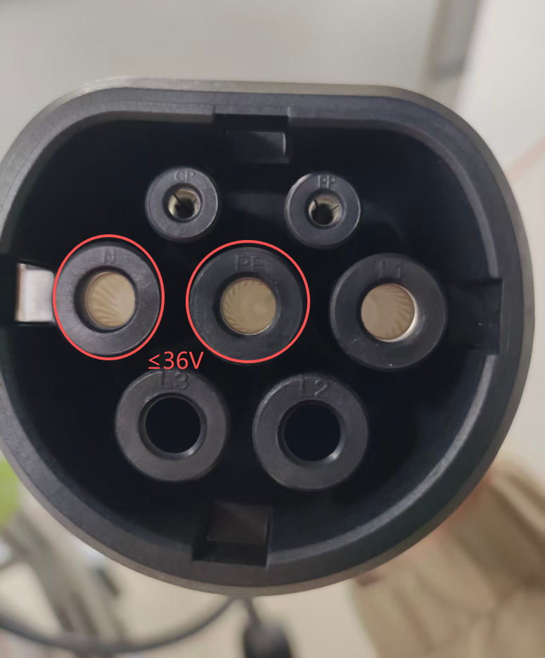
Step6-5 | Replace the ground wire and observe if the fault is eliminated after replacement.  If eliminated, the problem is solved.  If it is still not eliminated, contact the local after-sales team to handle it.

Typography requirements:
- The basic typography style is as above;
- The black font is a fixed title and cannot be changed; The green font is the part of adding content;

Text requirements:
- File Title:
"Product Line Abbreviation""Number" _ "Fault Name" SOP
Product line: INV inverter, BAT battery, BES energy storage cabinet, EVC charging pile;
Number: Each product line is numbered independently, starting from 0001;
Fault Name: Description as concise and refined as possible;

- Font: Standard Song (Chinese, English)
- Font size:
- Title: Two, bold, centered
- Text title: No. 5, bold
- Text: No. 5, not in bold
- Color: Black
- Line and paragraph spacing: 1.5 times
- Paragraph description (phenomenon, cause, treatment content): the first line is indented by 2 times

Image requirements:
- Format: JPG, PNG
- Size: It is recommended that within 300kb, the picture should not be too large and should not exceed 1M (if it exceeds, the picture size should be reduced)
- Video: If you have a video, you can take several pictures containing key information in a row

Attachment Requirements:
- Format: Uniform conversion to PDF
- Document title: uniformly named as "Product Line Abbreviation""Number" _Attachment Document Title_Serial Number (if there are multiple documents) "

