Battery Overtemperature Alarm and Protection Treatment SOP

- Fault Name:
- Battery overtemperature alarm
- Battery overtemperature protection
- Fault code:
- 546 (Battery Overtemperature Alarm)
- 578 (Battery Overtemperature Protection)
- Fault phenomenon:
- Battery overtemperature alarm: The system alarms that the battery is overheated, the battery is prohibited from charging, the battery discharge current is limited to 50%, and the BMS light is yellow + green
- Battery overtemperature protection: system alarm battery overtemperature, battery is prohibited from charging, discharging, BMS light is red
- Cause of failure: The ambient temperature is too high and the high load runs for a long time, the liquid cooling unit fails, the battery sampling wiring harness is disconnected, and the battery cell is abnormal.
- Applicable models:BES-P125X261E/BES-P125X261U
- Troubleshooting steps:
procedure | Contents | Example (picture or reference file)
Step1 | Confirm alarm data  The monitoring platform checks the time of battery overtemperature alarm, cell temperature, frequency, ambient temperature and load information.
Step2 | Analysis of remote alarm information  If the room temperature at the alarm time is 35℃ or above, and the equipment is running at full load, it is normal that the maximum temperature of the battery cell reaches 55℃ to trigger the battery overtemperature alarm.  When the system triggers an alarm and the system is loaded down, the battery temperature drops by 1~3℃ within five minutes, which means that the liquid cooling unit is working normally and does not need to be treated.  When the system triggers an alarm and the system is loaded down, the battery temperature does not drop significantly or increases instead of dropping within five minutes, and jump to Step3;  Step 4 to jump if the room temperature is below 35℃ at the alarm time and the equipment is not running with a high power load;
Step3 | Inspection of liquid cooling unit  Select "Liquid cooling Machine" in the "Battery Cabinet" interface of the monitoring platform.  Check Pressure Value  The Outlet pressure of the unit is about 0.5 bar higher than the Return pressure of the unit, indicating that the circulation pump is working and the liquid flows normally.  If the outlet and return water pressure is completely consistent or the pressure difference is too large, it means that the pressure performance of the liquid cooling unit is abnormal, and jump to Step5;  Check temperature values  The Outlet temp of the unit is approximately 0.5°C – 3°C lower than the Return temp of the unit, indicating that the battery is cooled normally and the liquid cooling capacity is normal.  The temperature at which the liquid-cooled unit starts cooling is 32℃.  When the temperature is higher than 35℃, the Outlet water temperature is consistent with the Return water temperature, which indicates that there is a problem with the cooling capacity of the liquid-cooled unit, and jump to Step5; | 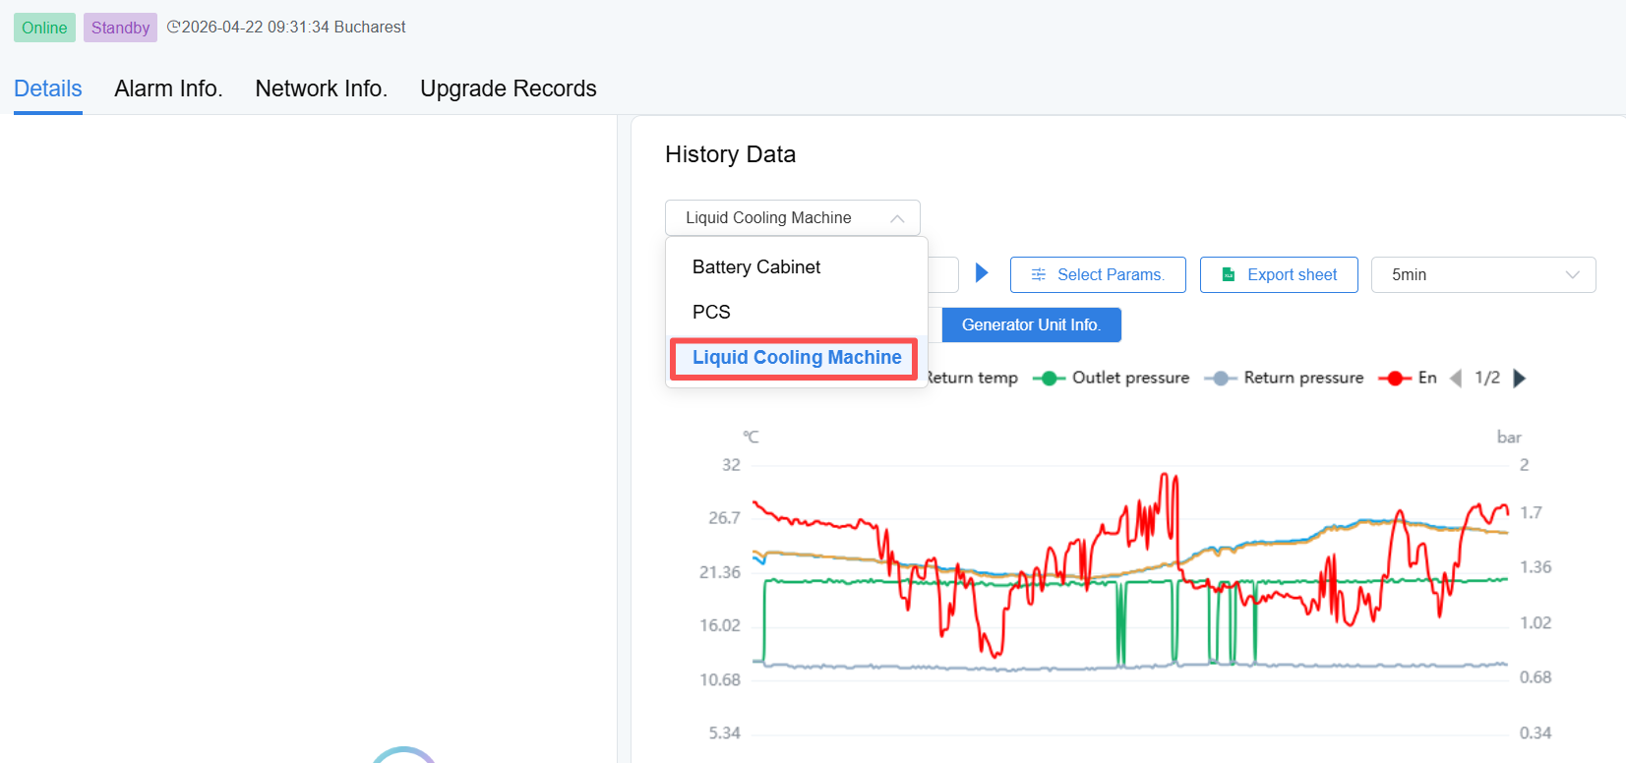  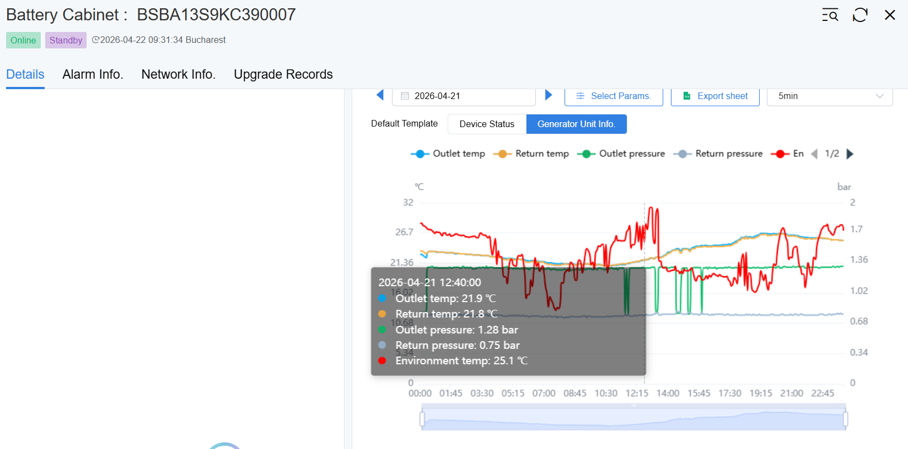
Step4 | Cell temperature comparison  In the "Battery Cabinet" interface of the monitoring platform, compare the maximum temperature (Cell temp high) and the minimum temperature (Cell temp low) at the alarm time.  If the temperature is found to occur-40°C (open circuit); 126℃ (short circuit), it means that the sampling harness of the battery is disconnected;  If the difference between the highest and lowest temperatures is ≥8~12℃, it may be that the battery cell is aging (large internal resistance);  Please contact the local after-sales service team for both of the above cases. | 