Battery Pack Temperature Sensor Abnormality Handling SOP

- Fault Name:Battery pack temperature sensor abnormal
- Fault code:None yet
- Fault phenomenon:Temperature acquisition abnormal alarm
- Cause of failure:Temperature sensor screw not tightened, BMU board damaged, harness damaged
- Applicable models:BES-P125X261kWh Energy Storage Cabinet
- Troubleshooting steps:
Before performing the following steps, please refer to the Operation Guide for Power-On and Power-Off of Energy Storage Systems for safe power-off.
procedure | Contents | Example (picture or reference file)
Step1 | First, pull out the cable terminal and check whether the Pin Pin of the BMU board is normal (the Pin Pin is broken and the Pin Pin height is uneven). If it is abnormal, please follow Step2. | 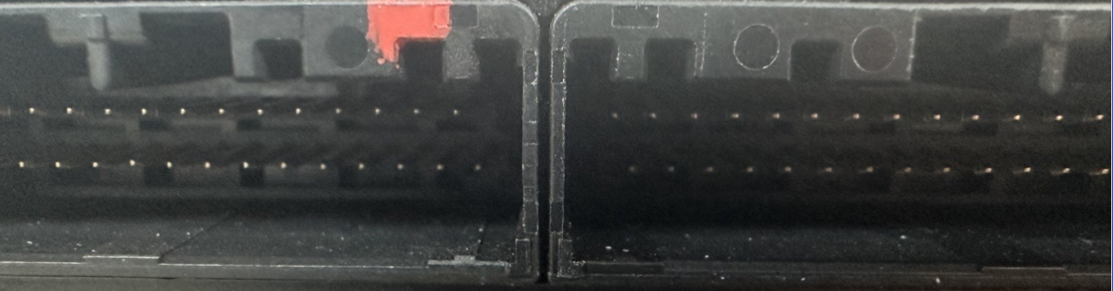
Step2 | Replacing BMU boards; If the fault is still reported after replacement, follow Step3.
Step3 | Use the on-off gear of the multimeter, and according to the installation distance, 1-2 people measure whether the temperature sampling wire harness is conductive; If it is not conductive, replace the sampling temperature harness; If it is turned on, press Step4.
Step4 | Remove the battery pack and check that the temperature sensor screws are tightened. If the screws are tightened, follow Step5.
Step5 | Please replace the temperature sensor and contact your local after-sales team if it remains abnormal.

