BESS Partial Battery Cabinet and PCS Offline Processing SOP

- Fault Name:None yet
- Fault code:None yet
- Fault phenomenon:
- Some battery cabinets and PCS are displayed offline on the monitoring platform
- Cause of failure:
- Communication abnormality between switch and PCS
- Corrupt communication line between switch and PCS
- Applicable models:BES-P125X261kWh
- Troubleshooting steps:
procedure | Contents | Example (picture or reference file)
Step1 | Check to see if the indicator light on the switch is working.  If the indicator light of the interface corresponding to the PCS on the switch is not lit, refer to Step2;  If the indicator light is green, refer to Step3; | 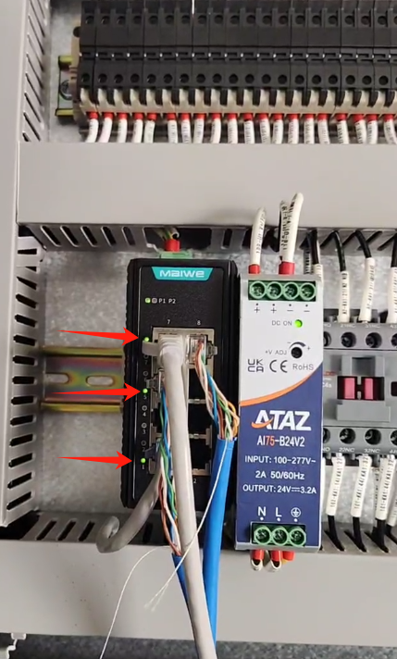
Step2 | Re-plug and unplug the communication line of the corresponding port on the switch. If it can be lit, refer to Step3;  If the indicator lamp is still not on, refer toStep4；
Step3 | inspectIs the "SYS" indicator on the PCS always on red, "POWER"Whether the indicator light is always green.  If not, refer to Step4;  If so, refer to Step 5; | 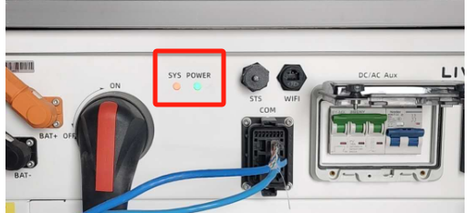
Step4 | Replace the communication line between the switch and the PCS.  If it returns to always on, refer to Step 5;  If it is still not always on, please contact the local after-sales service team to handle it.
Step5 | Turn off all blanks on the PCS, wait for the "SYS" indicator and "Power" indicator on the PCS to go off, turn on all blanks on the PCS, and check the monitoring platform after five minutes.  If the monitoring platform still displays offline, please contact the local after-sales service team. | 