BMS Communication SOP

- Fault Name:BMS Communication Fault Handling
- Fault code:335
- Fault phenomenon:Red light on battery cabinet
- Cause of failure:No communication between battery and PCS
- Applicable models:BES-P125X261
- Troubleshooting steps:
procedure | Contents | Example (picture or reference file)
Step1 | Check that the communication lines between the battery and the battery, and between the battery and the PCS are connected to the correct communication port of the device (as shown in the picture on the right, the PCS needs to select port COM-1-BMS).  If the connection is incorrect, refer to Step2;  If the connection is correct, refer to Step3; | BES 125kW/261kWh User Manual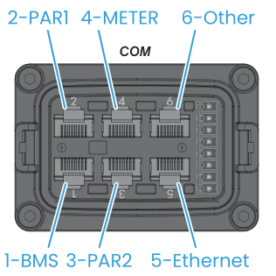
Step2 | After plugging the communication cable into the correct communication port, observe if the fault is eliminated.  If not eliminated, refer to Step3;  If eliminated, refer to Step9;
Step3 | Check for loose communication lines between battery and battery, battery and PCS.  If the communication cable is loose, refer to Step4;  If not loose, refer to Step5;
Step4 | Plug and unplug the communication cable again, verify that the communication cable is not loose, and observe whether the fault is eliminated.  If not eliminated, refer to Step5;  If eliminated, refer to Step9;
Step5 | Check the communication line for damage.  If the communication line is not broken, refer to Step6;  If the communication line is broken, refer to Step7;
Step6 | Check that the communication line sequence between the battery and the PCS is correct. If the line sequence is incorrect, refer to Step7;  If the communication line is correct, refer to Step8; | BES 125kW/261kWh User Manual  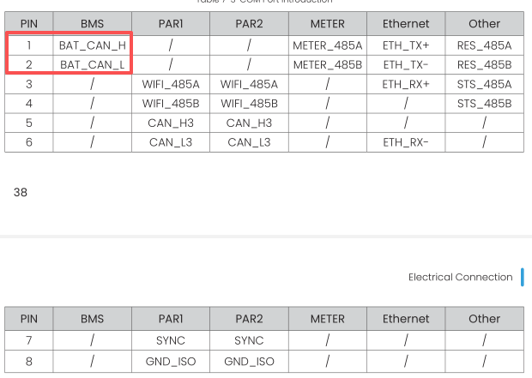
Step7 | Remake the communication cable according to the specifications of the user manual and observe if the fault is eliminated.  If not eliminated, refer to Step8;  If the fault is eliminated, refer to Step9; | BES 125kW/261kWh User Manual
Step8 | Check whether the communication port of the battery and the BMS communication port of the PCS are damaged or corroded.  If the communication port of the device is not damaged or corroded, please refer to Step10;  If the communication port of the device is damaged or corroded, please refer to Step11;
Step9 | Issue resolved.
Step10 | Contact your local aftersales team for remote support.
Step11 | Contact the local after-sales team to provide videos and pictures of the measurements for after-sales repair processing.

