IEMS Cannot Connect to Cloud Platform to Process SOP

- Fault Name:IEMS cannot connect to cloud platform
- Fault code:without
- Fault phenomenon:IEMS cannot connect to cloud platform
- Cause of failure:
- IEMS Program Version Low
- IEMS IP Address Misconfiguration
- SN not modified inside IEMS file
- IEMS Web Server does not enable the Livoltek Cloud Platform
- IEMS's SN is not manually added to the cloud platform
- Applicable models:HXMS-100
- Troubleshooting steps:
procedure | Contents | Example (picture or reference file)
Step1 | Check for access IEMS Web Server.  If you can't enter, the program version may be too low. Please contact the local after-sales service team.  If you can enter, refer to Step2;
Step2 | On the monitoring platform, click System Management-Options-Device SN Management to enter the SN number Management interface and check whether the IEMS SN has been manually added to the cloud platform.  If not added, the SN is supplemented in the cloud platform;  If added, refer to Step3; | 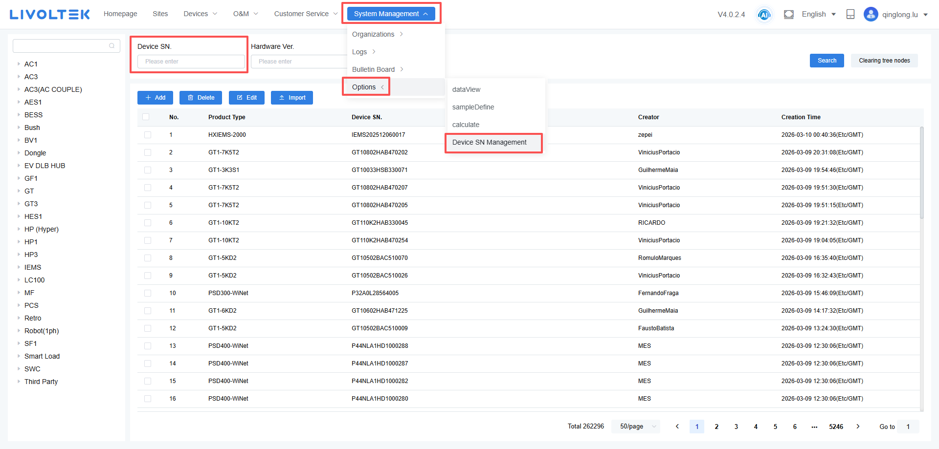
Step3 | Go to the Web Server page, check the SN in the bottom right corner, and check whether the SN inside the IEMS file has been correctly modified.  If the SN is inconsistent with the actual, contact the local after-sales service team to modify it;  If agreed, refer to Step4; | 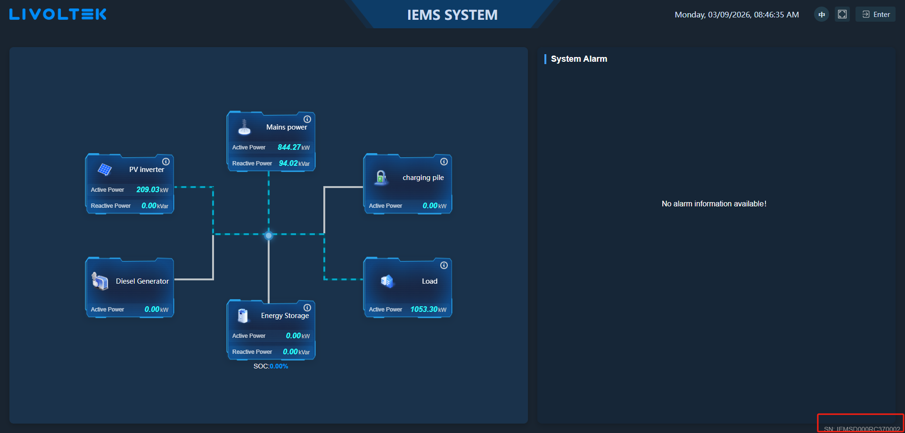
Step4 | Enter the Web Server interface and click System Setting-Remote Management to confirm whether the IEMS has turned on the Cloud Platform Enable option.  If not on, on;  If it is turned on, refer to Step5; | 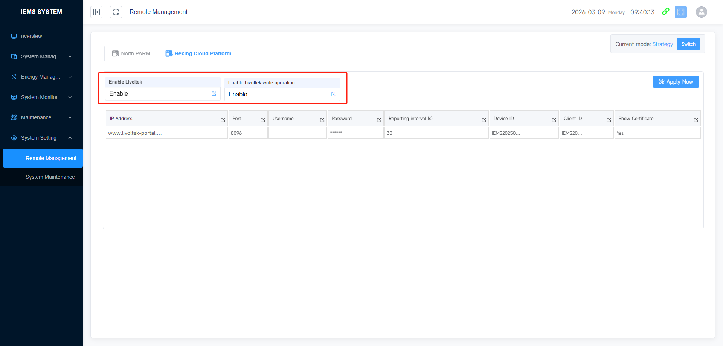
Step5 | Go to the Web Server interface and check if the cloud platform is offline while the Server is online.  If yes, click System Setting-System Maintenance to restart the IEMS.  If the cloud platform still displays offline after restart, contact the local after-sales service team for processing;  If online after restart, refer to Step6; | 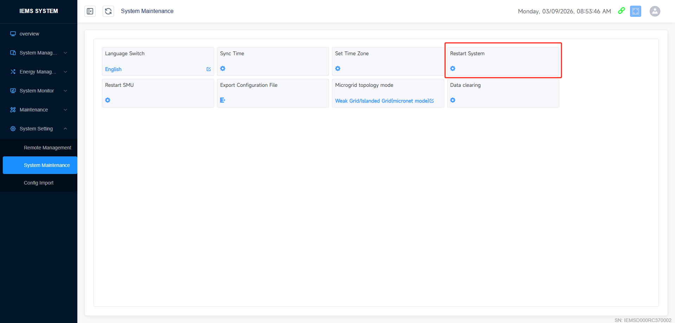
Step6 | Enter the Web Server interface and click System Setting-Remote Management to check whether the IEMS Web Domain Name Configuration (IP Address) is correct.  If the domain name iswww.livoltek-portal.com，Then the configuration is correct;  If not, refer to Step7; | 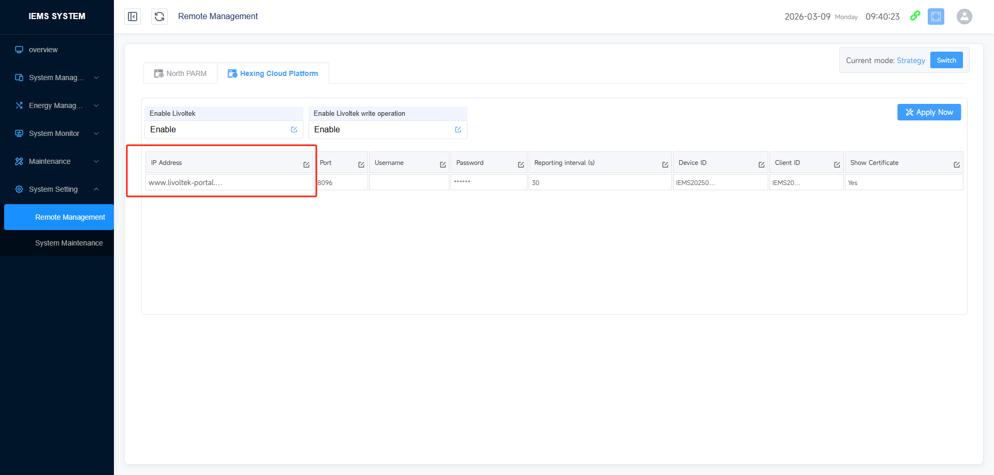
Step7 | If the above steps still do not solve the problem, please contact your local after-sales service team.

