IEMS Unable to Detect Connected Device Issue Handling SOP

- Fault Name:The IEMS cannot detect the connected device
- Fault code:None yet
- Fault phenomenon:Devices connected to IEMS are not displayed on IEMS WEB server or are displayed offline
- Cause of failure:
- No device added to the platform
- Communication cable is incorrectly wired and not properly connected to IEMS terminal
- The RS485 communication parameters on the Web server do not match the actual configuration (e.g., baud rate, device address)
- Applicable models:HXMS-100
- Troubleshooting steps:
procedure | Contents | Example (picture or reference file)
Step1 | Connect to IEMS WEB Server Check that the System Management-Device Config interface adds undetected devices;  If not added, refer to Step2;  As already added, refer to Step3; | 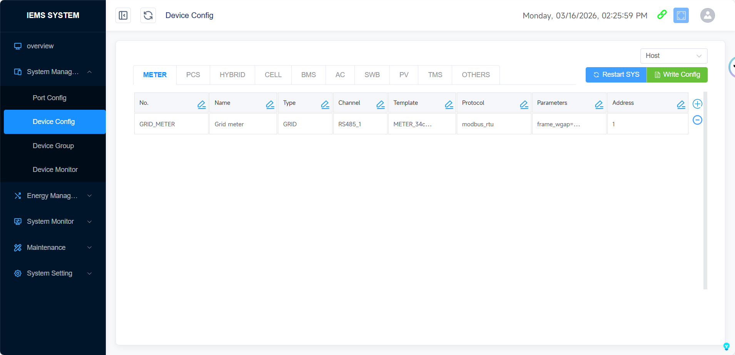
Step2 | Add a Device in the System Management-Device Config interface and check whether the Device is displayed normally;  If it is not displayed normally, refer to Step3;  If it is displayed normally, refer to Step9; | 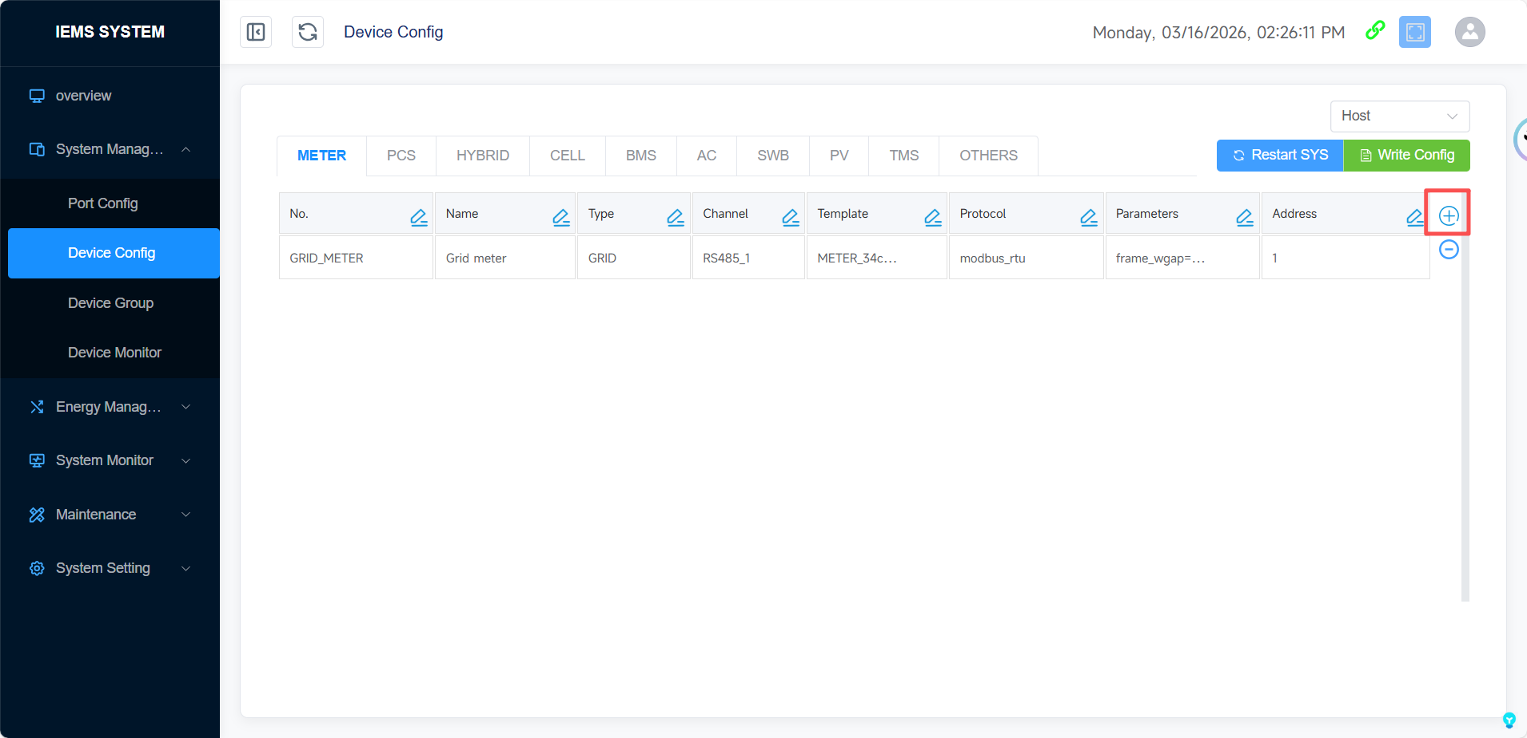
Step3 | Check whether the communication line connection between the equipment and the IEMS is normal;  If the communication line is not connected normally, refer to Step4;  If the communication line is connected normally, refer to Step5;
Step4 | After reconnecting the communication line, check whether the equipment is displayed normally;  If it is not displayed normally, refer to Step5;  If it is displayed normally, refer to Step9;
Step5 | Check whether the device communication parameters (baud rate, device address) are consistent with those set by WEB Server;  If it is inconsistent, refer to Step6;  If consistent, refer to Step7; | 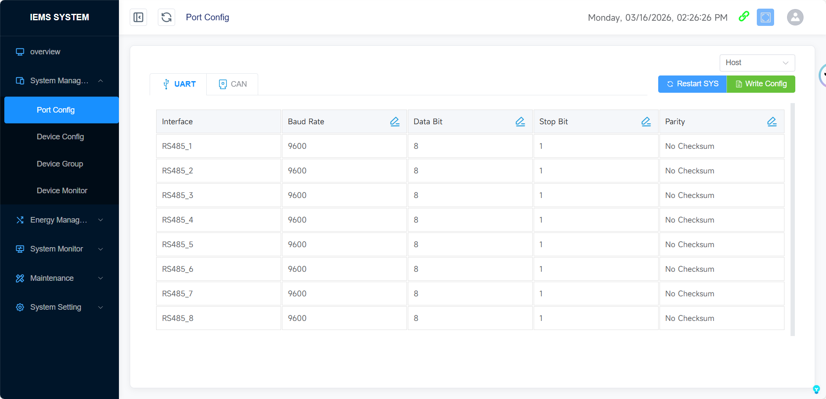  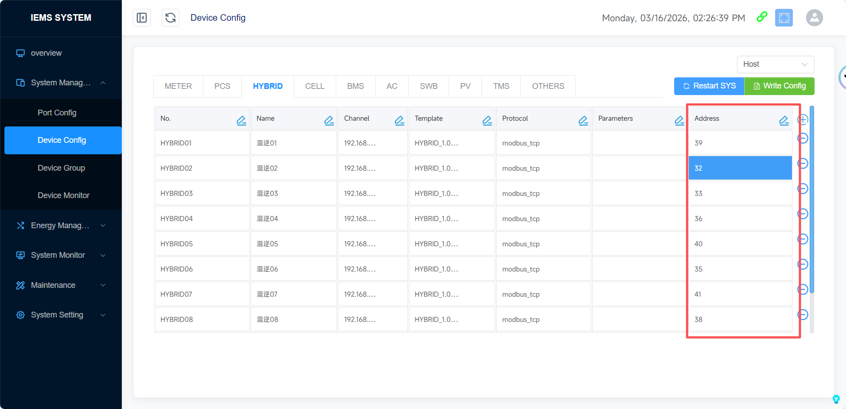
Step6 | Modify the communication parameters of the device or WEB Server to keep them consistent, and check whether the device is displayed normally;  If it is not displayed normally, refer to Step7;  If it is displayed normally, refer to Step9;
Step7 | Check if the undetected device is connected to the same RS485 port as other devices and the device address is duplicate;  If the addresses are duplicated, refer to Step 8;  If the addresses are not duplicated, refer to Step 10;
Step8 | Ensure that the addresses of all devices connected to the same RS485 are not duplicated, modify the addresses of undetected devices in the WEB Server interface, and check whether the devices are displayed normally;  If it is displayed normally, refer to Step9;  If it is not normally displayed, refer to STEP 10;
Step9 | Issue resolved.
Step10 | Please contact your local after-sales team for processing.

