PCS Communication Trouble Handling SOP

- Fault Name:PCS communication failure
- Fault code:None yet
- Fault phenomenon:PCS offline from IEMS website/PCS offline from portal
- Cause of failure:PCS communication wiring abnormality/PCS24V auxiliary power failure
- Applicable models:PCS-125KG1
- Troubleshooting steps:
procedure | Contents | Example (picture or reference file)
Step1 | Go to the monitoring platform to check if the PCS is online.  If the PCS is online, the communication between the PCS and the IEMS is normal;  If the PCS is offline, the communication between the PCS and the IEMS is abnormal, please refer to Step2; | 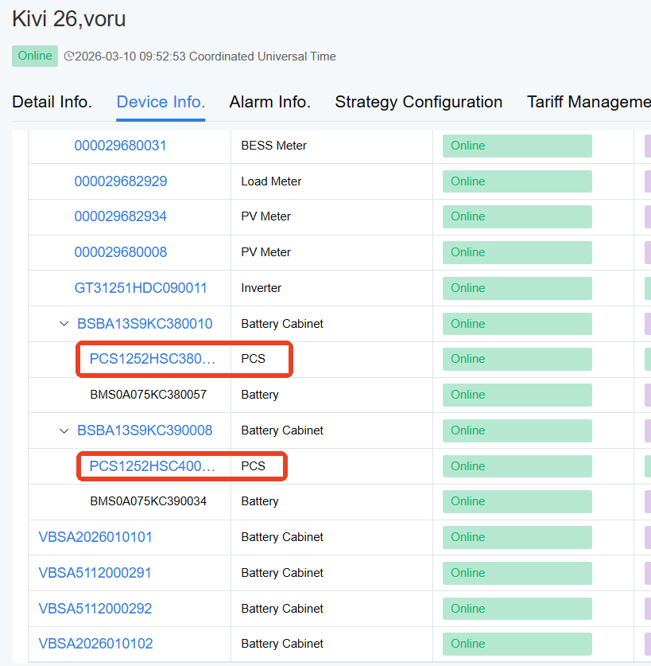
Step2 | Go to the IEMS Online System to check if the PCS is online.  In the monitoring platform site, find the IEMS device located at the top. There is a Remote Maintenance button next to the device. Click the button to go to the IEMS homepage.  Go to the editing page through Login in the upper right corner, the password is hx.iems, enter System Management-Device Monitor, select a PCS Device, and check the online situation.  If the PCS is online and the data is displayed normally, the communication between the PCS and the IEMS is normal;  If the PCS is offline and the data display is also red, the PCS communication is abnormal, please refer to Step3; | 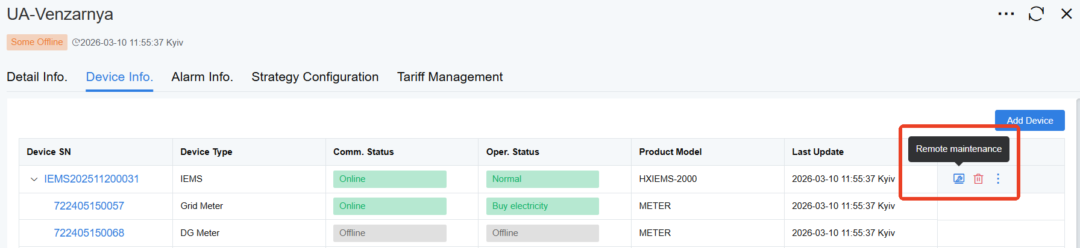    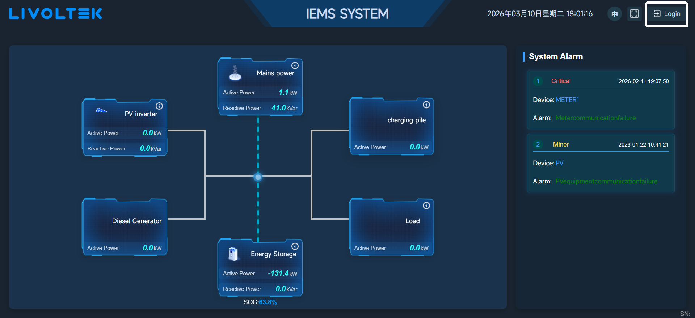    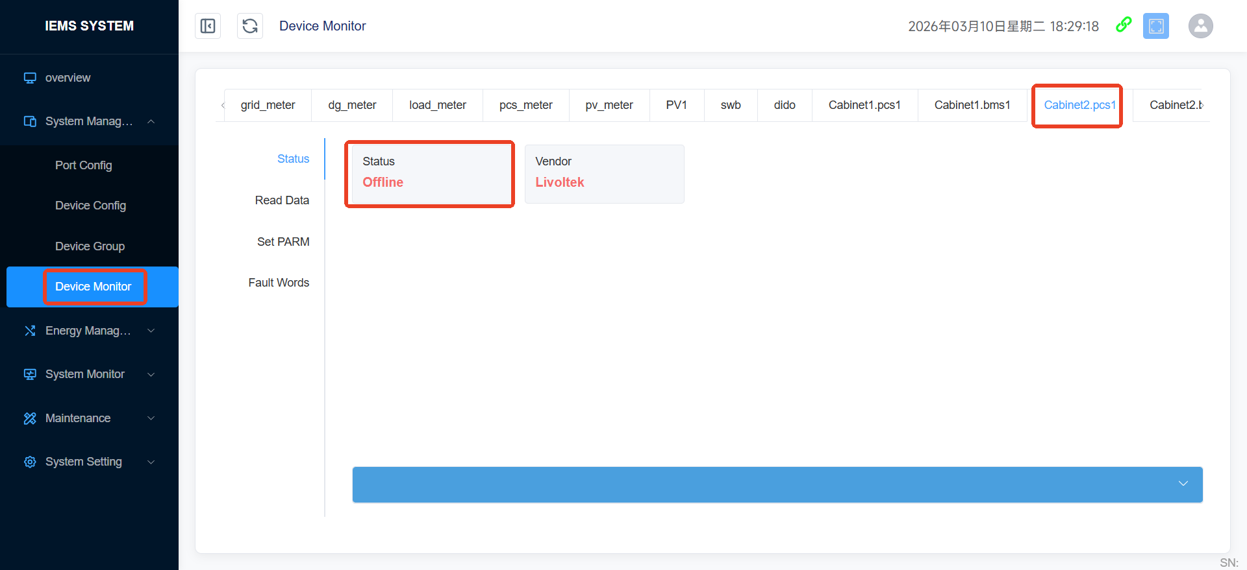
Step3 | Dispatch local technical support to the site to check the wiring status of PCS communication line, and determine whether there is a switching cabinet at the site.  If the site does not have a switching cabinet, refer to Step4;  If the site has a switching cabinet, please refer to Step5;
Step4 | Wiring method of PCS communication cable without switching cabinet:  In the pure grid-connected use scenario, the No.5 Ethernet port of the COM port of PCS equipment should be connected to the network switch, and the No.16 Ethernet port of the switch should be connected to the No.1 Ethernet port of IEMS (the RJ45 network cable adopts the standard line sequence). | Standard line sequence  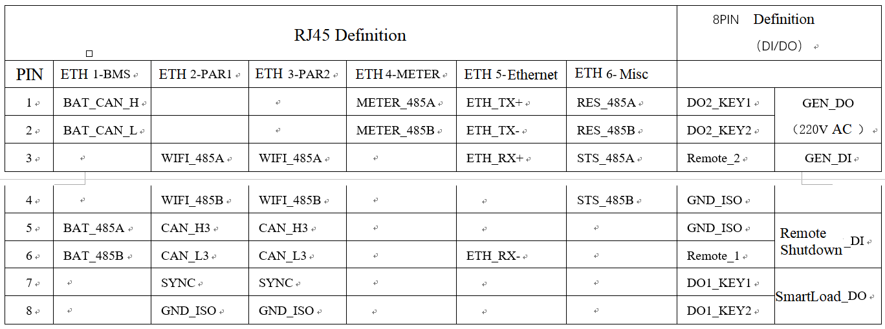
Step5 | Wiring method of PCS communication cable with switching cabinet:  In the scenario of parallel and off-grid switching, the No.2 and No.3 Ethernet ports of the COM port of PCS equipment are connected end-to-end (the parallel RJ45 network cable adopts a special line sequence (difference: swap Pin3 and Pin5));  The first PCS device shall be connected to the network switch through Ethernet port 5 (RJ45 network cable adopts standard line sequence), and Ethernet port 16 of the switch shall be connected to Ethernet port 1 of IEMS;  The last PCS device shall be connected to switching cabinet CAN2 through Ethernet port No. 3; The switching cabinet CAN1 is connected to the IEMS-CAN1; Install a 120 Ω terminal resistor at COM2 of the first PCS device.  If the PCS wiring is not loose or abnormal after inspection, refer to Step6 to check the power section. | Standard line sequence  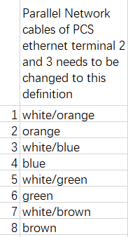  Special line sequence of 2 and 3 parallel machine lines  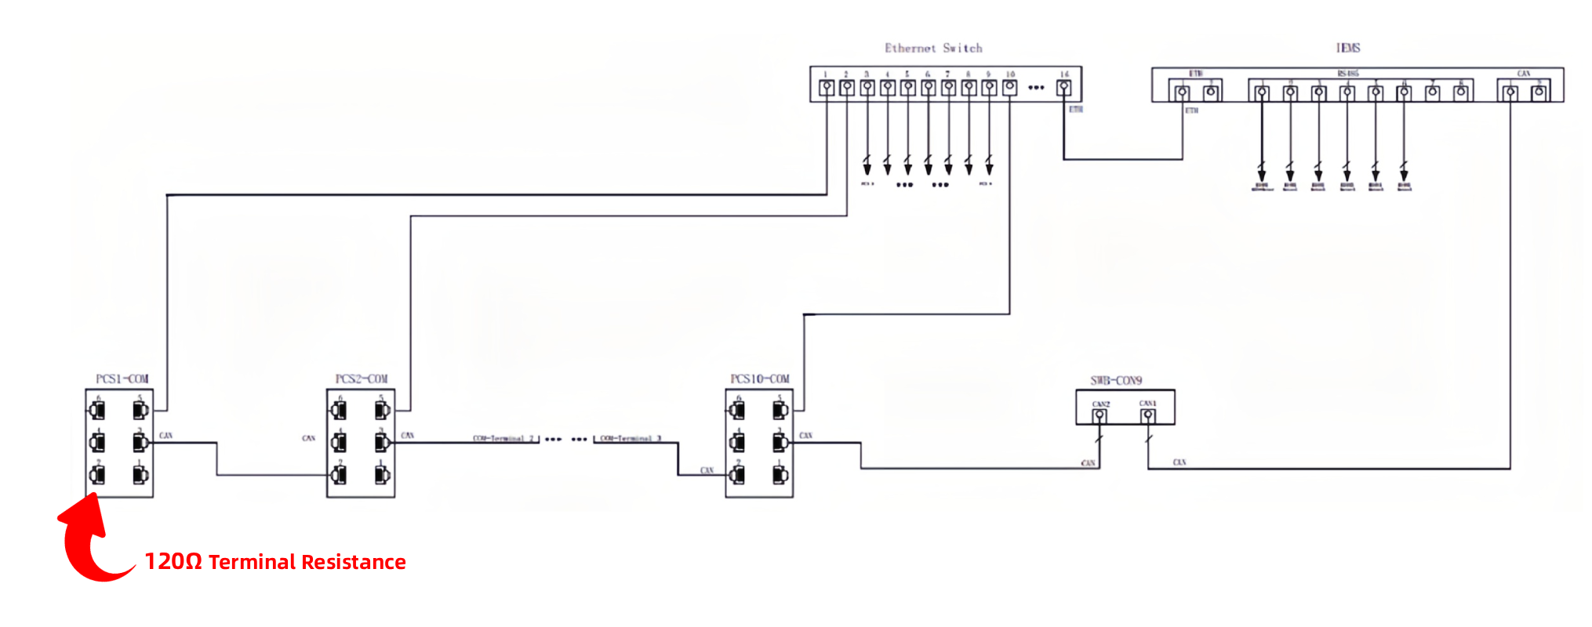
Step6 | PCS is dually powered by the battery cabinet and the mains power. Please first check whether the battery cabinet supplying power to PCS is powered off;  If so, refer to Step7;  If not, please contact the local after-sales service team for processing.
Step7 | Please continue to check whether the battery cabinet is tripped due to low battery;  If yes, please refer to "SOP for high voltage fault handling under battery cabinet";  If not, refer to Step8;
Step8 | Please check that the mains supply to the PCS is disconnected;  If yes, please refer to SOP for disposal of system off-grid caused by grid voltage sudden rise/drop;  If it is in normal grid-connected operation state, please contact the local after-sales service team for processing.

