PCS Overvoltage SOP

- Fault Name:Grid overvoltage
- Fault code:1, 2, 13, 14
- Fault phenomenon:PCS cannot be connected to the grid to feed power, and the monitoring platform fault alarms the grid overvoltage
- Cause of failure:The grid voltage is higher than the grid protection parameter and the high voltage duration exceeds the set HVRT value.
- Applicable models:PCS-125KG1
- Troubleshooting steps:
procedure | Contents | Example (picture or reference file)
Step1 | Please confirm the alarm information on the monitoring platform, and record the alarm time, equipment number and duration. | 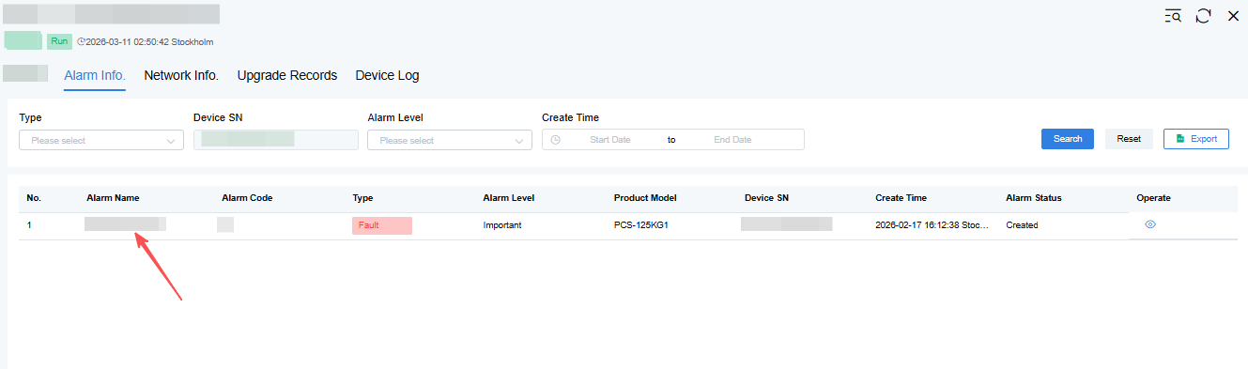
Step2 | Check protection parameters:  1. Check the mains voltage recorded by PCS during the alarm time;  2. Check whether the overvoltage protection point set by PCS is lower than the default value of safety regulations;  (At present, PCS country settings and protection point settings can only be set and checked through the SUNSPEC host computer. The version update in April 2026 will support IEMS settings.)  When alarming, if the mains voltage is higher than the protection point and lower than the safety requirements, the setting is adjusted back to the default value, and the alarm disappears;  When alarming, if the mains voltage is higher than the safety requirements, please refer to Step3; | 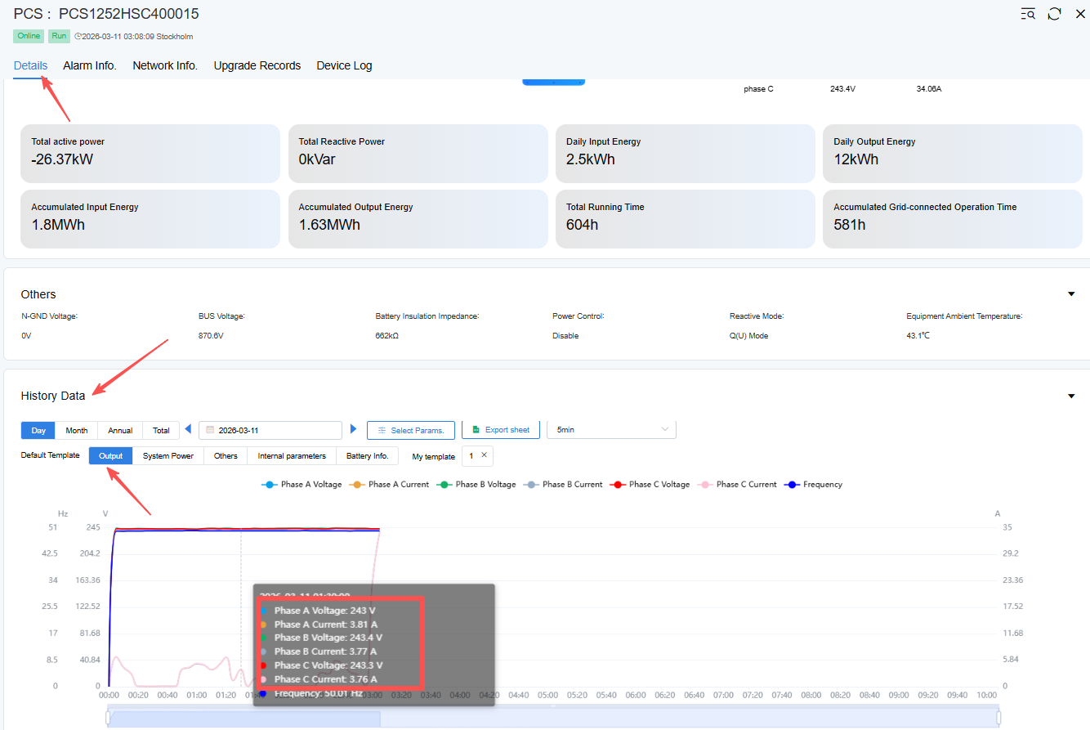
Step3 | After the PCS is powered off and discharged, the grid voltage is measured.  Turn off the PCS battery switch, DC circuit breaker, AC circuit breaker to ensure that the equipment is disconnected from the grid; Wait at least 10 minutes for the internal capacitor to fully discharge. Use the measuring instrument to confirm that there is no residual voltage at the BESS mains port.  Measurement operation:  When it is confirmed that it is safe, re-close the grid-side circuit breaker to energize the grid connection point. Connect the multimeter or analyzer to the three-phase ports (L1, L2, L3, N) of the grid-connected point to measure the voltage phase by phase, and record the phase voltage value. Compare whether the measured grid voltage value is consistent with the PCS sampled voltage:  1. If the measured value is consistent with the sampled value, it means that the grid voltage is too high. Please contact the local power grid company for processing;  2. The difference between the measured value and the sampled value is more than 5%, please refer to Step4;
Step4 | When the power is disconnected, check the connection between the PCS mains and the ground wire.  1.Turn off the PCS battery switch, DC circuit breaker, AC circuit breaker to ensure that the equipment is disconnected from the grid.  Use a multimeter to verify that there is no voltage at the port to ensure safety.  The wait time should be greater than or equal to 10 minutes to allow the internal capacitor to fully discharge.  2. Inspection of municipal power lines  - Appearance inspection: Confirm that the insulation layer of the municipal wire is not damaged or burnt.  - Terminal Inspection: Check whether the terminals are firm and avoid loose or dummy connections.  - Ground inspection  - Appearance inspection: Confirm that the ground wire is well insulated and free of breakage or corrosion.  - Ground Terminal Check: Check that the ground terminal is securely connected to the ground bar.  If the line has broken skin or is not firmly installed, please make rectification according to the installation manual;  If the wiring is installed properly, please contact your local aftermarket team for support.

