Abnormal Communication Handling SOP between High-volt Battery and Inverter

- Fault Name:Abnormal communication between high-voltage battery and inverter
- Fault code:335
- Fault phenomenon:
- Inverter cannot read battery soc
- The cell voltage of the battery cell is 0V (as shown below)
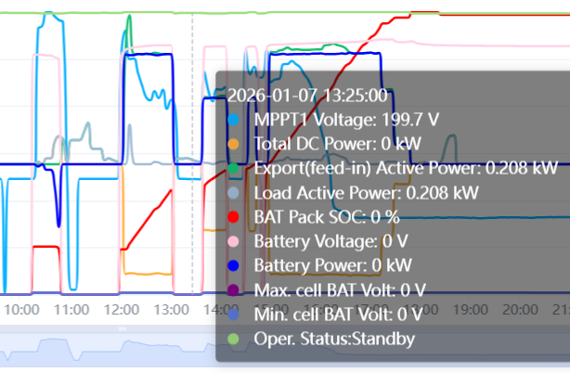
- Cause of failure:
- Cell voltage is too low, BMS trips and disconnects from inverter
- Corrosion or damage of BMS communication port
- BMS Communication Line Poor Communication
- Applicable models:BHF-S-G2/G4
- Troubleshooting steps:
procedure | Contents | Example (picture or reference file)
Step1 | Go to the LIVOD monitoring platform to observe the high-voltage battery soc and single cell voltage.  If the single cell voltage is below 2.8V, it belongs to the case of <cell voltage is too low, BMS trips and disconnects from the inverter>, please refer to "SOP for High Voltage Battery SOC Too Low Protection Treatment".  If the single cell voltage is above 2.8V, jump to Step2; | 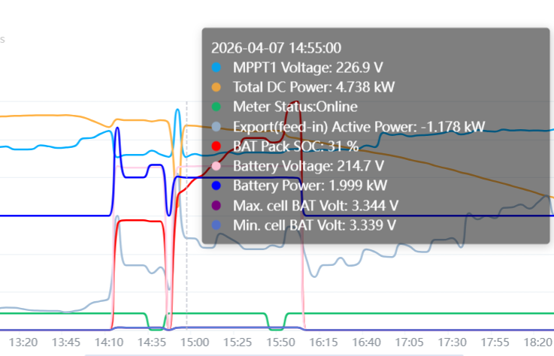  Figure 1: Single cell voltage above 2.8V
Step2 | Replace the port of the communication line connected to the BMS with another (if COM1 was used before, then replace it with COM2, and if COM2 was used before, then replace it with COM1), and verify whether the other communication port can obtain communication normally  If communications can be obtained, the problem is resolved.  If communication cannot be obtained, jump to Step3;
Step3 | Check whether the communication ports COM1 and COM2 of the BMS of the high-voltage battery are not damaged or corroded.  If so, jump to Step6;  If there is no obvious damage, jump to Step4; | 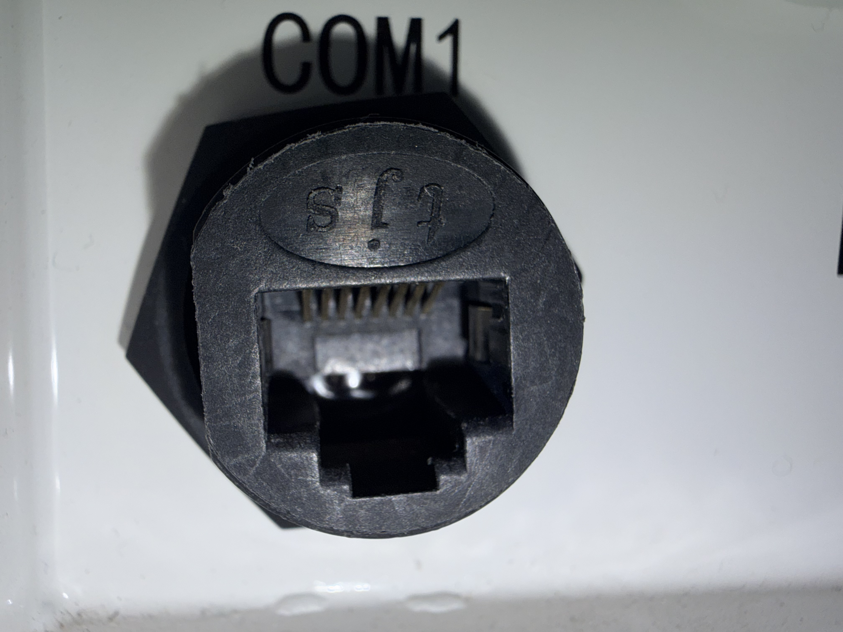  Figure 2: Check whether the Pin inside the communication port is intact, contaminated, corroded, and structurally damaged as shown in the figure
Step4 | The definition of the communication line connected to the BMS terminal of the high-voltage battery shall be the same as that of the line sequence connected to the inverter terminal. Check whether the line sequence of the communication line pins is the same at both ends.  If it is different, one end of the non-standard network cable line sequence should be cut and re-crimped to ensure that the line sequence (468B line sequence) at both ends is the same.  If the same, jump to Step5; | 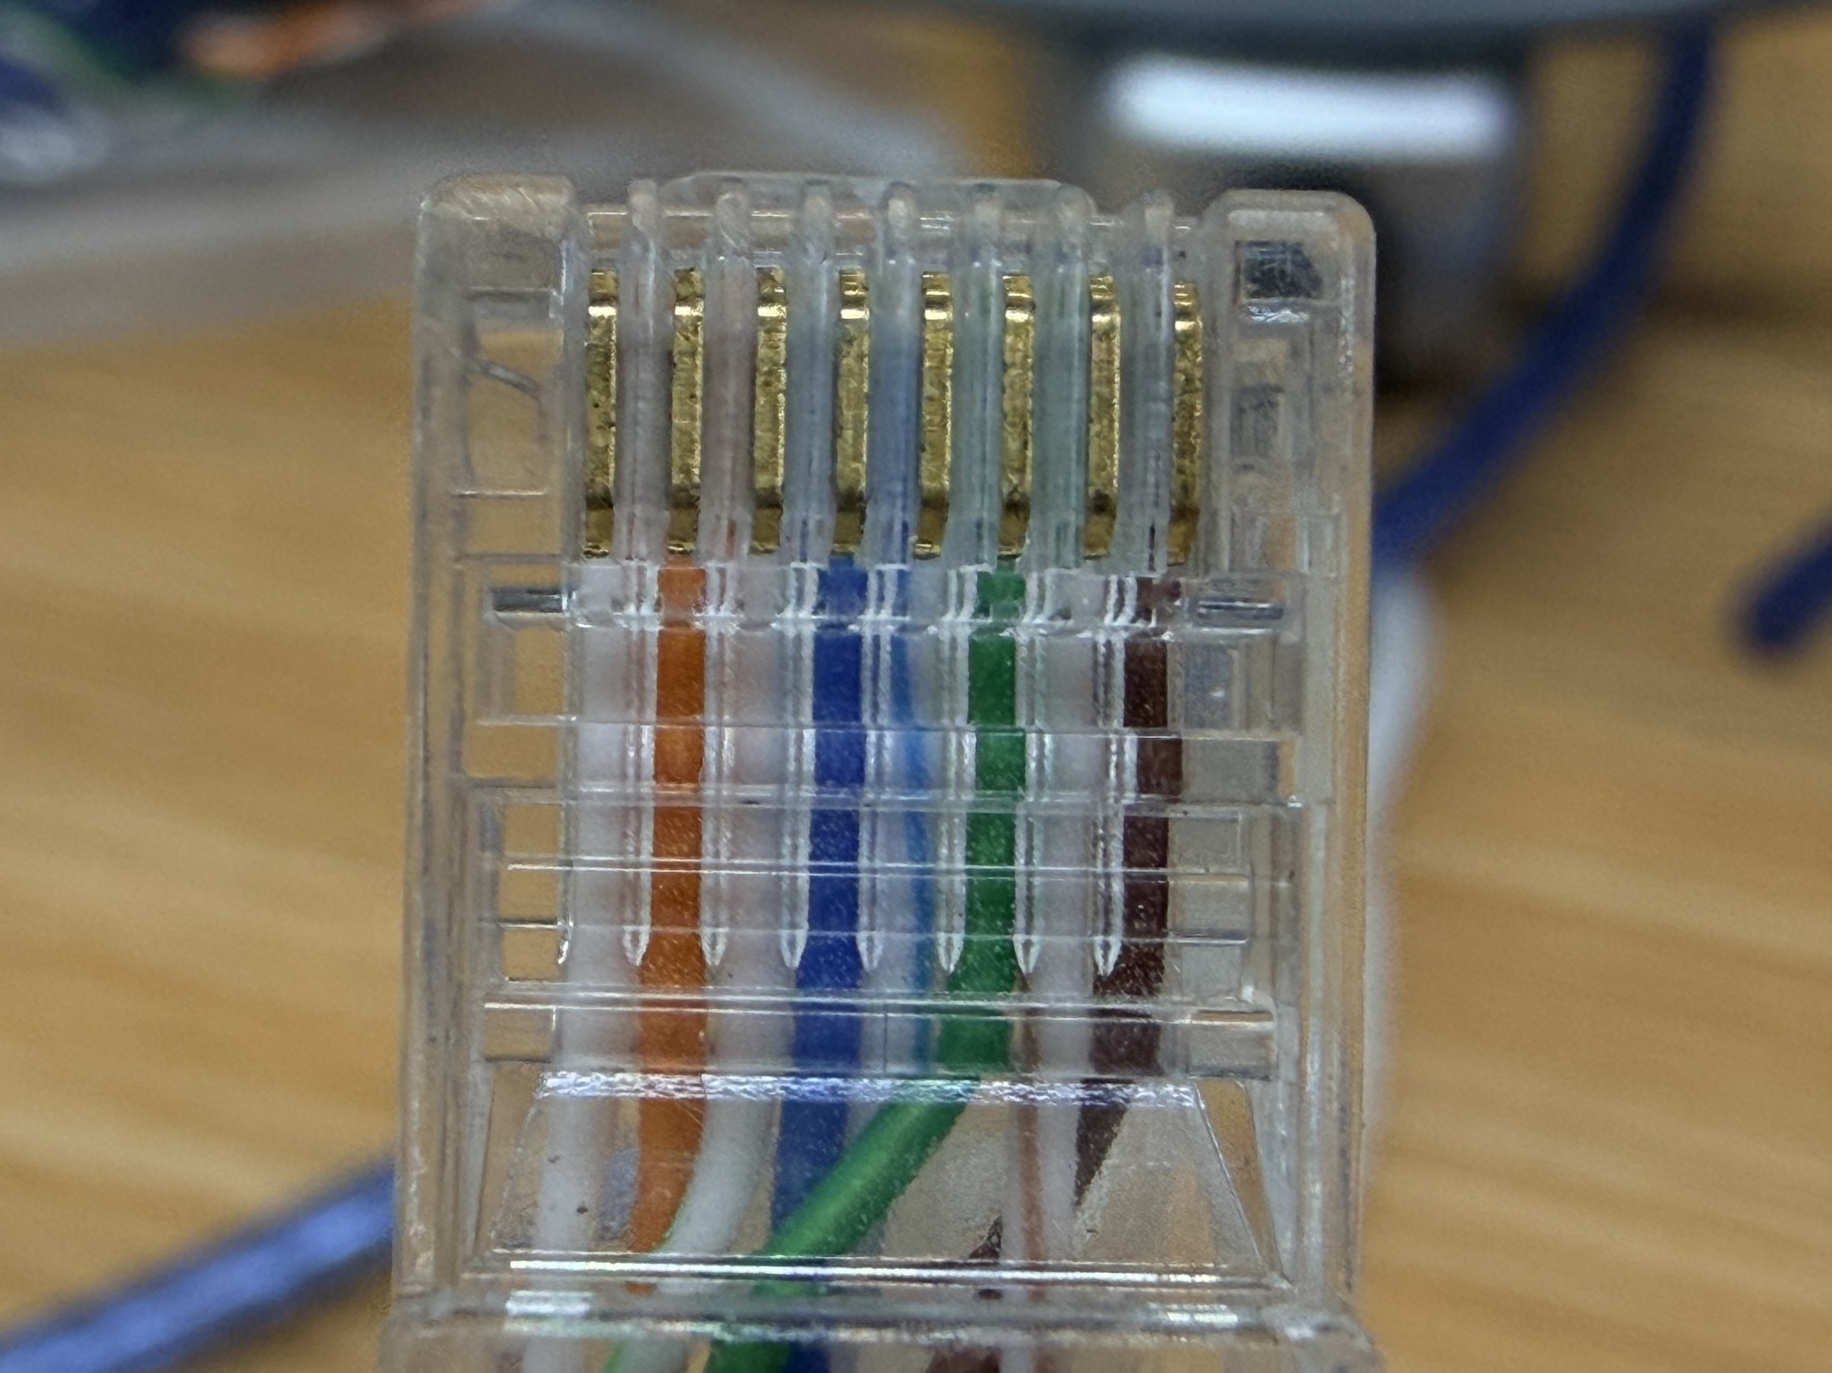  Figure 3: As shown in the figure, the standard network cable (national standard) is defined as orange/white, orange, green/white, blue, blue/white, green, brown/white, brown
Step5 | Use the network cable or crystal head on hand to re-press the cable or buy a new network cable. Use the multimeter buzzer file to measure the smooth communication of each pin at the head and tail, and reconnect the communication cable.  If the communication still cannot be restored, jump to Step6;
Step6 | Please contact the local after-sales service team to handle it.

