BMS Communication Loss Alarm Handling SOP

- Fault Name:BMS Communication Loss
- Fault code:F3 00004000
- Fault phenomenon:
- Monitoring platform SOC values disappear
- Abnormal communication between inverter and battery
- No battery light bar on the inverter screen
- Battery's indicator lights go out
- Cause of failure:
- BMS communication port is blocked by foreign objects, corroded, etc., resulting in communication failure
- Communication interference or communication instability
- Communication line abnormality causing communication failure
- Applicable models: Hyper ~3-6kW, BLF51-5;
- Troubleshooting steps:
procedure | Contents | Example (picture or reference file)
Step1 | Check whether there is obvious foreign object blockage or water corrosion in the BMS communication port of the battery and the inverter.  If there is blockage or corrosion, please refer to Step2;  If there is no corrosion phenomenon, please refer to Step3; | 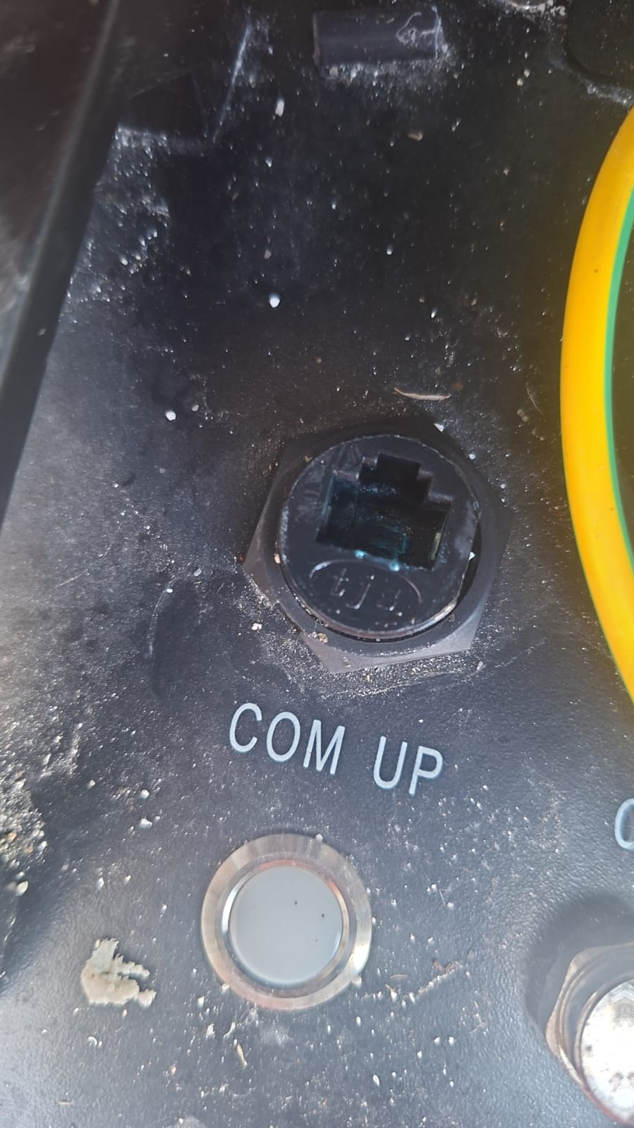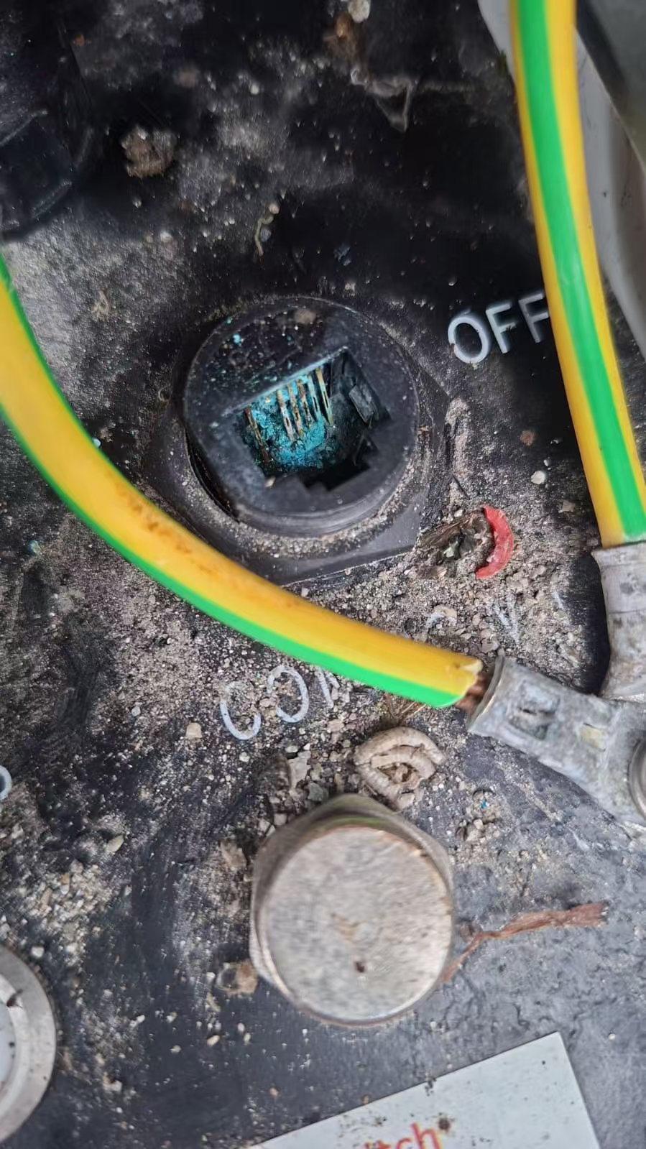
Step2 | Clean the BMS communication port, remove foreign objects and reconnect the battery communication cable to observe whether the fault is eliminated.  If there is no foreign object in the communication port, but the fault has not been eliminated, please refer to Step6;
Step3 | Check that the end of the battery is connected to the terminal resistor (if the batteries are connected in parallel, check the last battery).  If the terminal resistor is not connected, jump to STEP 4;  If the terminal resistor is connected, jump to STEP 5; | 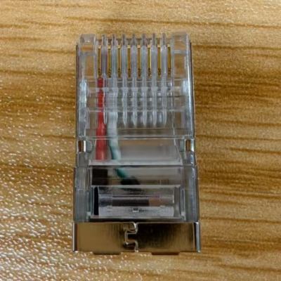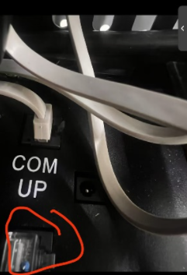
Step4 | Connect the terminal resistor (included in the battery accessory pack) and observe if the fault is eliminated.  If the terminal resistor is connected, but the fault is not eliminated, jump to Step5; | 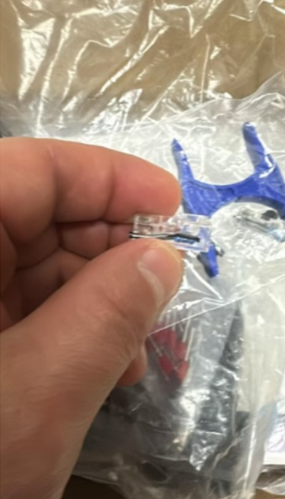
Step5 | Check the abnormal points of the following battery communication lines, replug and unplug or remake and connect them, and observe whether the fault is eliminated:  - Communication cable not tightly plugged  - Communication line sequence error  - Corrosion of communication lines  If none of the above problems exist in the battery communication cable, but the fault has not been eliminated, please contact your local after-sales service team. | 