Firmware Version Mismatch Handling SOP

- Fault Name:Firmware version mismatch
- Fault code:F2 0000 4000
- Fault phenomenon:The inverter is in a faulty state, and the firmware version mismatch fault is reported
- Cause of failure:DSP1 firmware does not match DSP2 firmware
- Applicable models:HYPER-3~6kW
- Troubleshooting steps:
procedure | Contents | Example (picture or reference file)
Step1 | It is found that the inverter is in a fault state on the monitoring platform, enter the details page to view the current version of the inverter, and jump to Step2; |   
Step2 | Firmware version mismatch faults usually occur between DSP1 and DSP2.  Check whether the DSP1 and DSP2 firmware versions are single firmware (4.0.X) and parallel firmware (3.0.X).  See example for checking method:  If there is mixed use of single-machine and parallel firmware between DSP1 and DSP2, jump to Step3;  If both DSP1 and DSP2 are stand-alone firmware (not 3.0.X), jump to Step4; | Go to Monitoring Platform <Monitoring Platform>, enter the device SN in order, search, and click the device SN to enter the device details  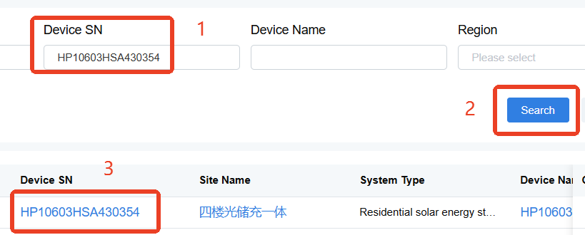  The inverter firmware Version can be viewed at <Version info> at the bottom of the device details page  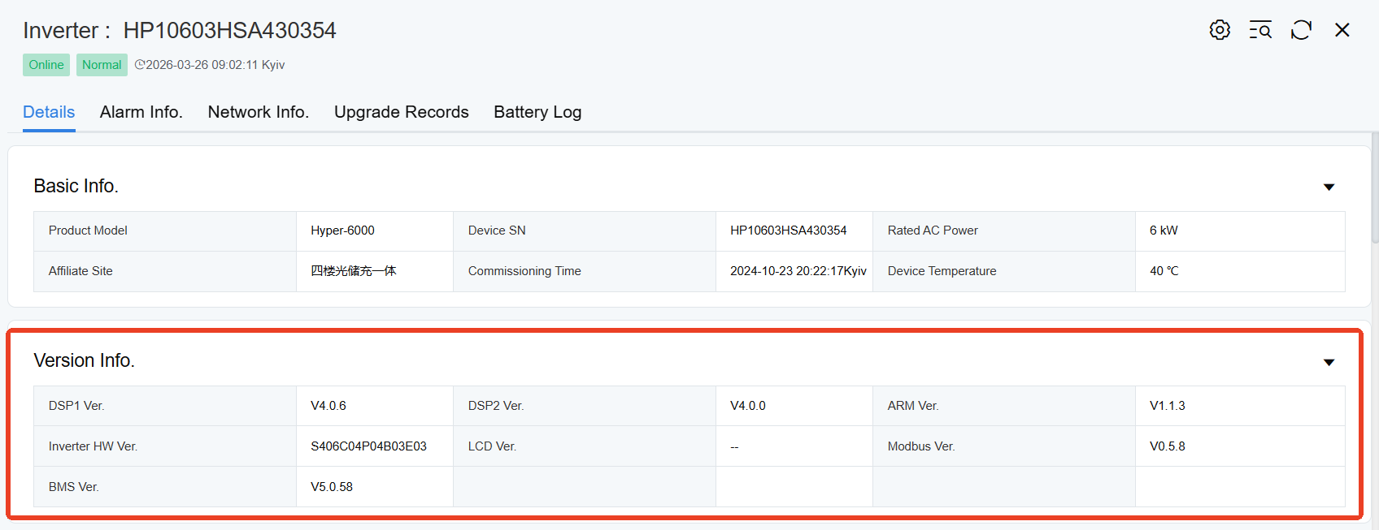
Step3 | Confirm the purpose of the inverter after mixing the firmware of single machine and parallel machine.  If the inverter is for stand-alone use, update both DSP firmware to the latest (4.0.X) stand-alone firmware;  If the inverter is used in parallel, update both DSP firmware to (3.0.0) parallel firmware.  (See Appendix for recommended firmware combinations) | Mixed use case of single-machine and parallel firmware:  Arm v1.1.3  DSP1 v4.0.6  DSP2 v3.0.0  DSP1 uses the latest firmware of the single machine and DSP2 uses the parallel firmware, resulting in a mismatch of the firmware
Step4 | If both DSP1 and DSP2 are stand-alone firmware and there is mismatch, the span of the two firmware versions is too large, and all of them need to be updated to the latest.  (See Appendix for recommended firmware combinations) | 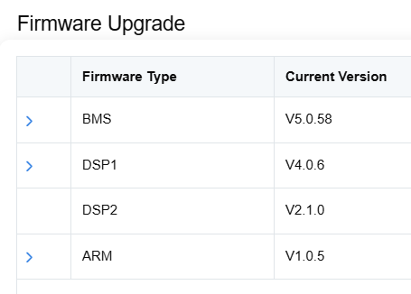  As shown in the figure, DSP2 standalone firmware is too old and does not match the latest DSP1 firmware. At this time, the inverter reports firmware mismatch fault

Appendix:
Firmware combination | Application
Arm v1.1.3 DSP1 v4.0.6 DSP2 v4.0.0 | Single Inverter (Latest)
Arm v1.0.6 DSP1 v4.0.3 DSP2 v4.0.0 | Single Inverter (Second New)
Arm v9.4.3 DSP1 v9.4.3 DSP2 v4.0.0 | Single-machine inverter diesel generator adaptation
Arm v1.1.2 DSP1 v3.0.0 DSP2 v3.0.0 | Parallel inverter

