Grid Overvoltage&Undervoltage Alarm Processing SOP for Hybrid Inverter

- Fault Name:Grid Volt Abnormal
- Fault code:F1 00000100
- Fault phenomenon:Inverter Grid Related Icon Not Lighting
- Cause of failure:The grid voltage exceeds the voltage protection range set by the inverter
- Applicable models:Hyper 3000-6000
- Troubleshooting steps:
procedure | Contents | Example (picture or reference file)
Step1 | Check the grid voltage in the historical data interface of the monitoring platform, and check the grid voltage value. If the voltage value is 0, refer to step2; If the voltage value is not 0, refer to Step 3. | 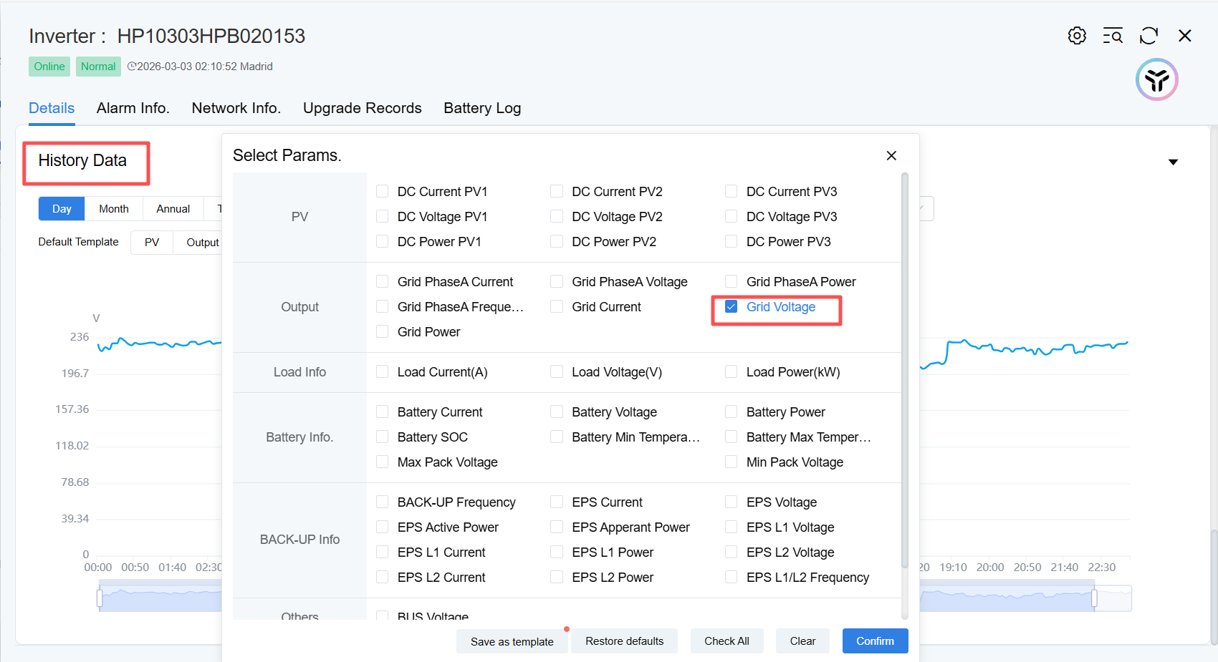  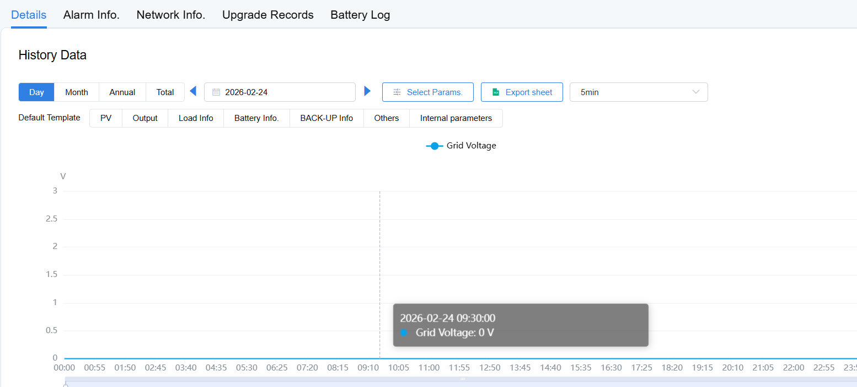
Step2 | Check whether the grid-side open is tripped. If the grid-side open is tripped, refer to Step4; If the grid-side open is not tripped, refer to Step5.
Step3 | Explain that the actual grid voltage is outside the set range.  Check the grid voltage range set in the Advanced Settings-Grid Protection Parameters of the LIVOLTEK Monitoring Platform.  Main check parameters: over-voltage protection point 1/2, under-voltage protection point 1/2.  According to the actual local grid regulatory voltage, adjust the protection point value, and the acceptable adjustment range is ±20% of the regulatory voltage.  After adjustment, observe whether the grid indicator lights up normally. If the indicator lights up normally, refer to Step10; If the indicator light is not on, the actual grid voltage exceeds the regulatory grid voltage by ±20%. Refer to Step12. | 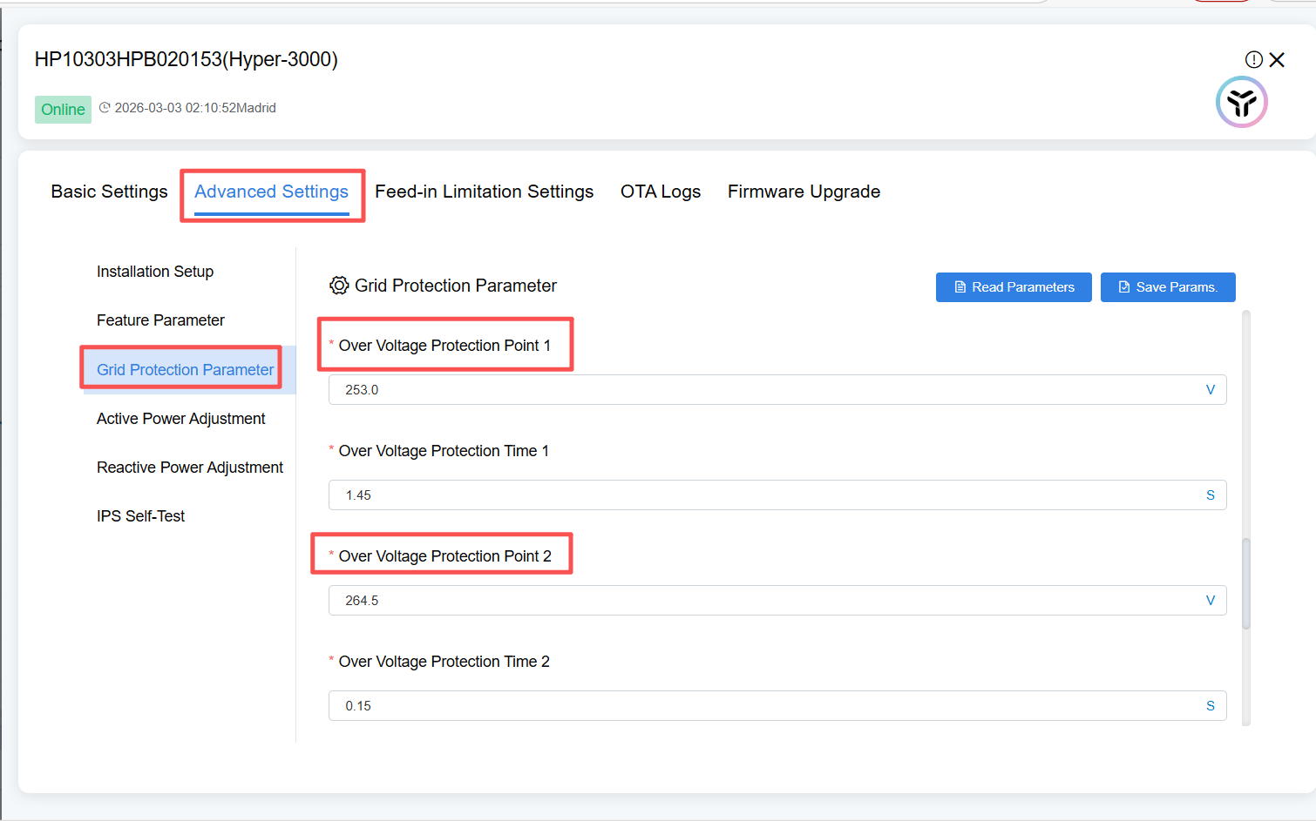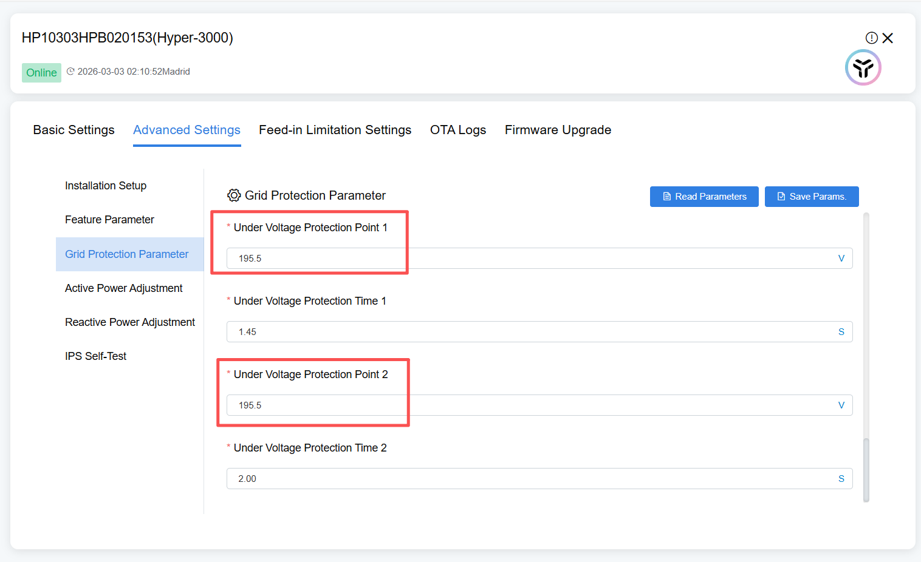
Step4 | Close the grid-side opening and observe whether the grid indicator light of the inverter is on normally. If illuminated, refer to STEP 10; If the grid indicator is not illuminated, refer to Step7.
Step5 | Disconnect the grid-side open and check for voltage at the grid terminals on the inverter side with a multimeter. If there is a voltage, refer to Step 6; If there is no voltage, refer to Step 7.
Step6 | Disconnect the grid-side air switch, connect the grid-side terminals normally, and ensure that there is grid voltage at the grid terminals. Close the grid-side opening and observe whether the grid indicator light of the inverter is on normally. If it illuminates normally, refer to Step10; if it does not, refer to Step11.
Step7 | Disconnect the grid-side air switch, and open the terminal to check whether the internal grid power line is virtually connected. If virtualized, refer to Step8; if not, refer to Step9.
Step8 | Disconnect the grid-side open. And connect the power grid terminals normally, close the space on the power grid side, and observe whether the power grid indicator lamp can light up normally. If it illuminates normally, refer to Step10; if it does not, refer to Step11.
Step9 | Connect the grid terminals normally, close the grid-side space, and check whether the grid indicator light is on. If it is on normally, refer to Step10; If it is not on, refer to Step11.
Step10 | Issue solved
Step11 | Contact local after-sales personnel to provide measurement videos and pictures for after-sales replacement processing
Step12 | If the actual grid parameters are less than ±20% of the local regulatory voltage, contact the local grid company for grid-side inspection

