High-volt Battery Cell’s Large Voltage Difference Protection Treatment SOP

- Fault Name:High voltage battery cell voltage difference is too large
- Fault code:None yet
- Fault phenomenon:Too fast battery charge and discharge speed is accompanied by jump, and the battery capacity decreases and the discharge amount decreases
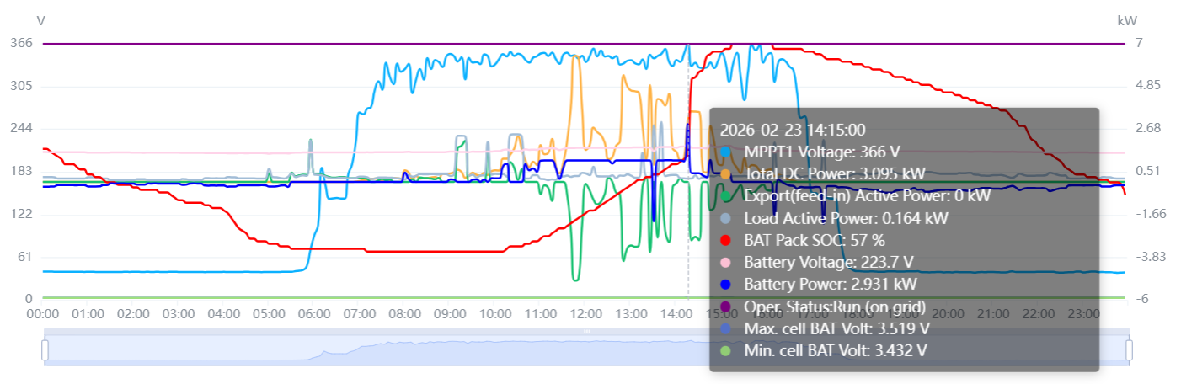
- Cause of failure:
- Mixed use of new and old batteries
- Batteries do not belong to the same lot
- Applicable models:BHF-S
- Troubleshooting steps:
procedure | Contents | Example (picture or reference file)
Step1 | Platform cell voltage judgment:  Through the difference between the maximum cell voltage and the minimum cell voltage of the platform, the maximum cell voltage difference should be about 15mV in the standing state, the maximum voltage difference should be below 250mV when the battery is fully charged, and the maximum voltage difference should be below 300mV when the battery is fully discharged;  Phenomenon 1: The voltage difference at the end of charging of the battery is between 15mV-250mV, and the end of discharge is between 15mV-300mV (see national standard GB/T 36276-2023 for details);  Phenomenon 2: the pressure difference between 250mV and 400mV when the battery is fully charged, and the pressure difference between 300mV and 400mV when the battery is fully discharged;  Phenomenon 3: the cell voltage difference is above 400mV;  Phenomenon 1 indicates normal battery operation  Phenomenon 2, Phenomenon 3 Jump to step2 | Reference National Standard GB/T 36276-2023  5.3.1.3 Battery clusters  The initial charge and discharge performance of the battery cluster under the rated power condition shall meet the following requirements:  a) the initial charging energy is not less than the rated charging energy;  b) the initial discharge energy is not less than the rated discharge energy;  c) the initial charge and discharge energy efficiency is not less than 95.0%;  d) the range difference of the cell voltage at the end of charging is not more than 250mV;  e) the range difference of cell voltage at the end of discharge is not more than 300mV;  f) the range difference of the battery cell temperature at the end of charging is not more than 6 DEG C;  g) that temperature range of the battery cell at the end of the discharge is not more than 6 DEG C;  h) the range difference of the battery module voltage at the end of charging is not greater than 5.0% of the nominal voltage of the battery module;  i) The battery module voltage range at the end of discharge is not greater than 5.0% of the nominal voltage of the battery module.
Step2 | Judgment of pressure difference between battery packs or pressure difference within battery packs:  If phenomenon 2 is observed, confirm whether the voltage difference appears in the package room or in the package through the maximum cell voltage number and the minimum cell voltage number of the platform. The single battery pack of BHF-S consists of 32 cells, which are directly connected; The highest bit of the BMS has a battery pack number of 1 and a cell number of 1-32;  Phenomenon 1: Pressure difference appears in the private room  Phenomenon 2: Pressure differential occurs in the pack  Phenomenon 1 Jump to step3  Phenomenon 2 Jump to step4 | 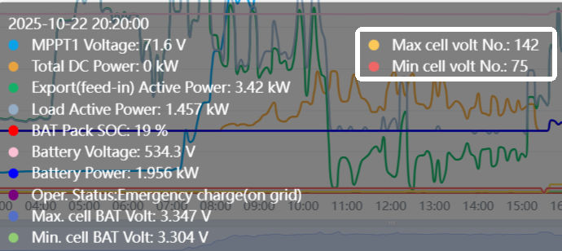  As shown in the figure, the highest cell voltage appears at 142, the lowest cell voltage appears at 75, and there are 32 cells per pack, so the highest cell voltage appears in pack 5 and the lowest cell voltage appears in pack 3
Step3 | Each pack of batteries is fully charged using a second generation three-phase energy storage unit (HP3-xxKD2/KT2):  It is necessary to send two installers to the site, change the wiring of the battery, install only one BHF-S battery between the BMS and the base, use the backup mode or user-defined mode to fully charge the battery, and repeat this operation until all batteries are fully charged separately; | 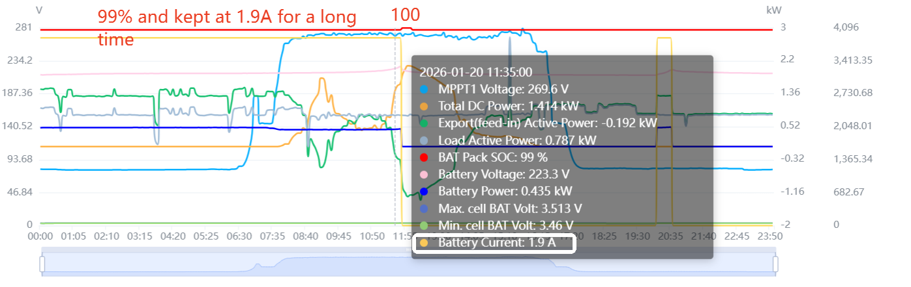  It should be noted that full charge can only be confirmed when the battery reported 100% soc and the cell voltage reached 3.6V and slowly dropped back
Step4 | The single-pack batteries were fully charged and allowed to stand using a second generation three-phase energy storage machine (HP3-xxKD2/KT2):  It is necessary to send two installers to the site to change the battery wiring, install only one BHF-S battery between the BMS and the base, use the backup mode or user-defined mode to fill the single battery, and then let it stand for 1 hour;

