High-volt Battery Short-circuit Handling SOP

1. Fault name:
- Battery Short Circuit
- Battery Overtemperature Protection
2. Fault code:
- 584 (battery short circuit fault)
- 578 (Battery Overtemperature Protection)
3. Fault phenomenon:The inverter reports that the battery is short-circuited, and the battery pack emits white smoke or spontaneous ignition.
4. Cause of failure:Short circuit caused by broken cable, internal battery failure
5. Applicable models:
- BHF-S
- BHF-G
6. Troubleshooting steps:
procedure | Contents | Example (picture or reference file)
Step 1 | Remote Shutdown, in the settings of the Inverter of the monitoring platform, click Basic Setting-Inverter Control-Shutdown in turn. | 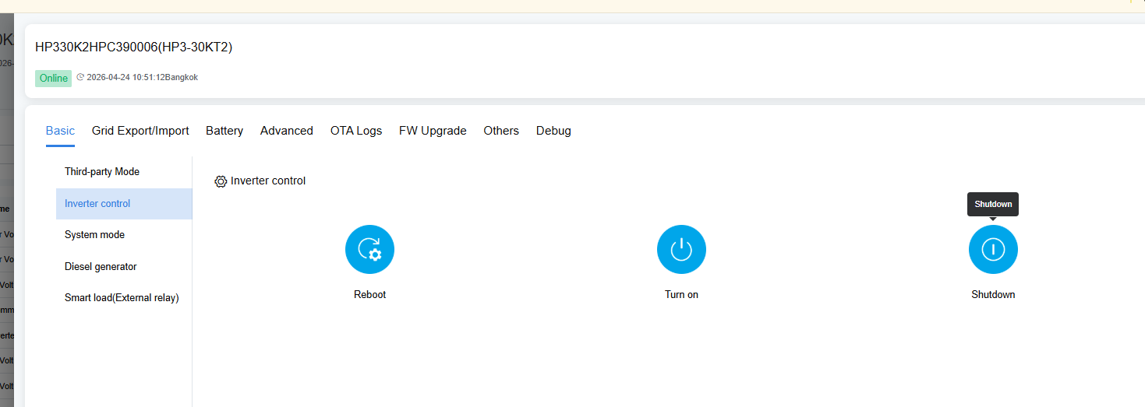
Step2 | Sequentially disconnect the AC air switch on the mains side, disconnect the air switch of the battery BMS, and disconnect the DC air switch of the inverter.
Step3 | Safety protection tips: A safety warning area greater than or equal to 5 meters is designated on the spot. Personnel must work in the upwind direction throughout the process, and wear 1000V high-voltage insulating gloves, insulating shoes and goggles with a complete set of high-voltage protective equipment.  If you find that the battery is smoking/heating, please use dry sand and fire blanket to cover the isolation and cool down. It is strictly forbidden to put out the fire with water and foam fire extinguisher!  After the processing is completed, isolate the faulty short-circuit battery cluster or faulty module first, and then contact the local after-sales service team for processing.
Step4 | If no battery smoke/heat is found, check the battery power cord for damage first.  If so, shutdown replacement is performed first.  If not, please contact the local after-sales service team to handle it.

