High-volt Battery SoC Low Protection Treatment SOP

- Fault Name:High voltage battery SOC too low protection
- Fault code:None yet
- Fault phenomenon:
- The battery single pack voltage is higher than 80V, the single cell voltage is higher than 2.5V, and it has not starved to death. It keeps communication with the inverter and can still respond to the inverter request (if the battery single pack voltage is lower than 80V, the single cell voltage is lower than 2.5V, and it has starved to death, please refer to "SOP for dealing with starvation of high-voltage battery SOC too low");
- The battery SoC remains below 10% for a long time, and the inverter does not charge the battery; Or the battery SOC is not accurate (it still shows that it is higher than 10%), but the cell voltage is below 3.00V, the actual SOC is already lower than 10%, and the inverter does not charge the battery (as shown in the figure below);
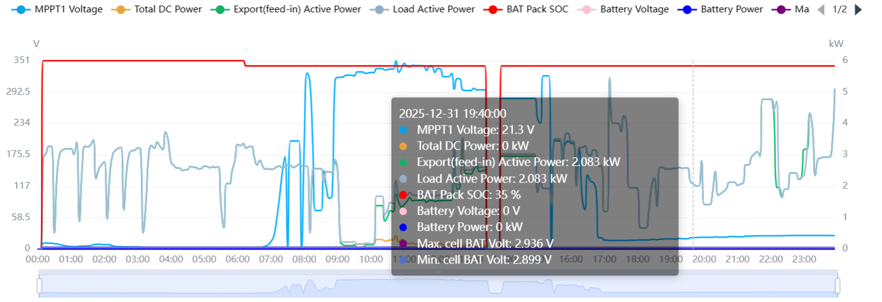
- Cause of failure:
- The battery firmware version is too low and the power replenishment logic is missing
- Abnormal communication between battery and inverter
- Inverter setup problem causing the inverter not to charge the battery
- Applicable models:BHF-S
- Troubleshooting steps:
procedure | Contents | Example (picture or reference file)
Step1 | Go to the monitoring platform, observe the BMS firmware version, and judge the BMS hardware version:  - When the BMS firmware version is v1.39/v1.49/v1.55 and the hardware version is G1;  - When the BMS firmware version is v1.1.2/v1.1.3/v1.1.4/v1.1.5 and the hardware version is G2;  - When the BMS firmware version is v6.0.0/v6.0.1/v6.0.2 and the hardware version is G4;  If it is the G1 hardware version, jump to Step2;  If it is the G2 hardware version, jump to Step3;  If it is the G4 hardware version, jump to Step4; | 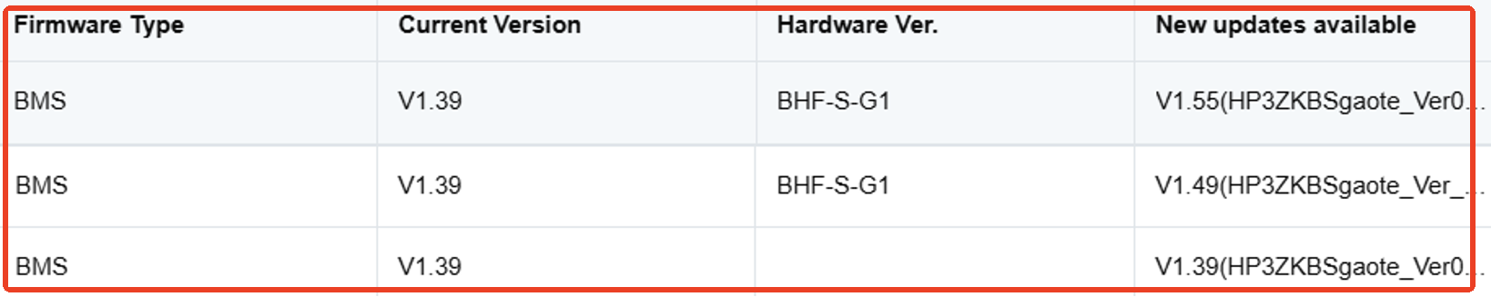  As shown above, this is hardware version G1;  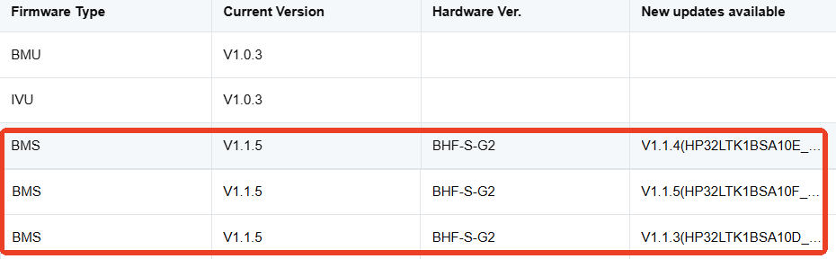  As shown above, this is hardware version G2;  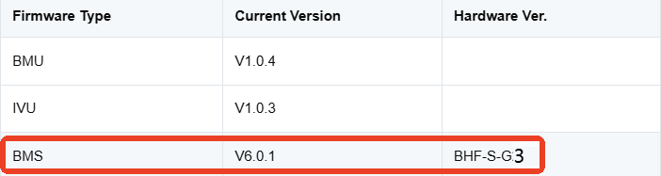  As shown above, this is the hardware version G4;
Step2 | The battery hardware version is G1, and the BMS firmware version is upgraded to v1.49/v1.55 and above, which will trigger emergency charging when the minimum cell voltage reaches 3.00V.  Charging will start automatically after upgrading to the new firmware. If charging does not start automatically, jump to Step4; | 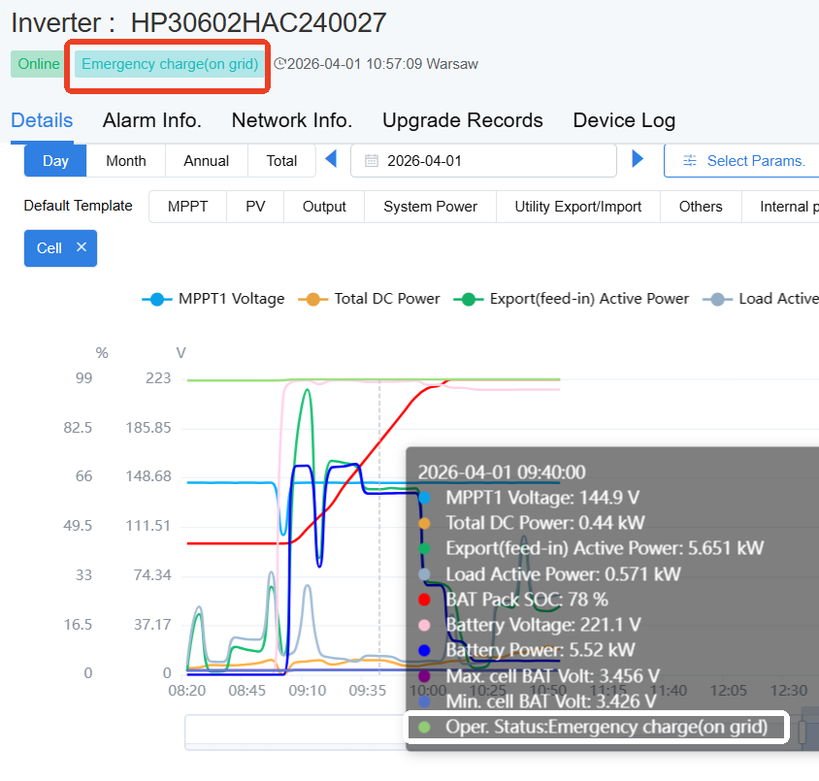
Step3 | The battery hardware version is G2, and the BMS firmware version is upgraded to v1.1.3/v1.1.4/v1.1.5 and above, which will trigger emergency charging when the minimum cell voltage reaches 3.00V.  Charging will start automatically after upgrading to the new firmware. If charging does not start automatically, jump to Step4;
Step4 | Charging does not start automatically, check if the inverter can read the total battery voltage and cell voltage.  If the inverter reads the total battery voltage, jump to Step5;  If the inverter cannot read the total battery voltage, jump to Step7;  If the inverter cannot read the cell voltage, please refer to SOP for communication abnormality handling between high-voltage battery and inverter; | 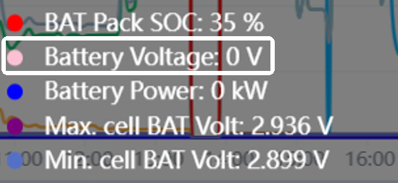  As shown in the figure, the inverter can only read the cell voltage, but not the total voltage;
Step5 | The inverter can read the "total battery voltage", and the battery MOS is closed. It is necessary to manually set the backup mode and raise the lower limit of battery SoC to 50%.  The battery will stop charging after reaching the lower limit of SOC, and the battery will return to normal. After that, it can be adjusted back to the spontaneous self-use mode and the original lower limit of SOC.  If the battery still does not start charging after setting the backup power, jump to Step6; | 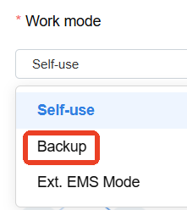  Set the backup mode and increase the lower limit of battery SOC;  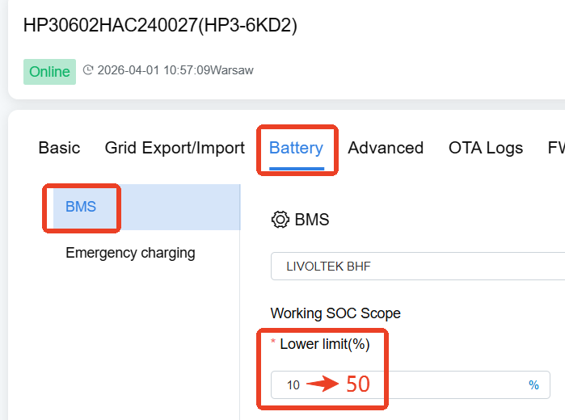
Step6 | Manually set the TOU custom charging period to charge the battery;  When the battery returns to normal, it can be adjusted back to spontaneous self-use mode and the original lower limit of SoC. | 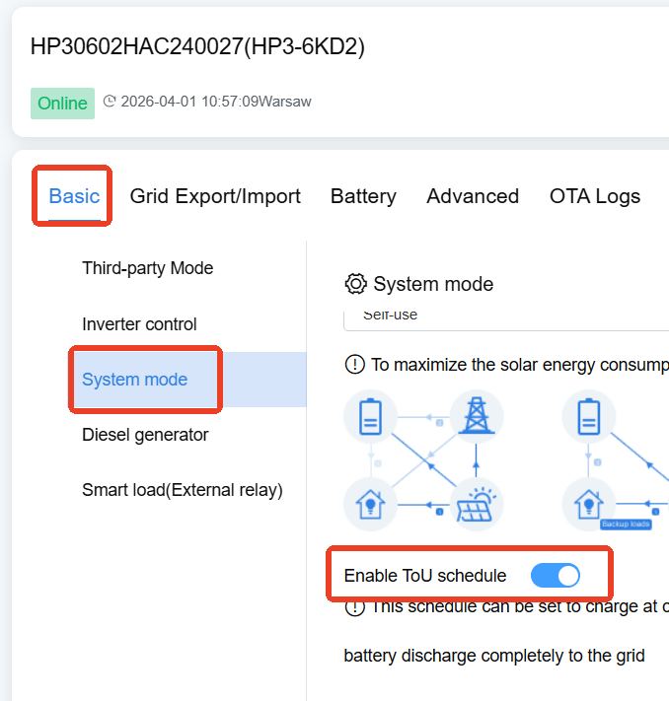  Enable TOU Charging  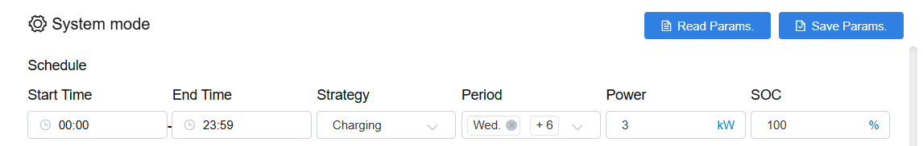  Set 0: 00-23: 59 every day, 7 days a week, the strategy is charging, the power is half of the rated power of the inverter, and the target SOC is 100%;
Step7 | The inverter cannot read "Total Battery Voltage", which means that the battery MOS is disconnected and the battery cannot respond to the charge and discharge command of the inverter.  Please try rebooting the battery BMS remotely.  If the inverter can read "total battery voltage" after remotely restarting BMS, jump to Step5;  If the inverter still cannot read the "total battery voltage" after remotely restarting the BMS (that is, the battery MOS remains disconnected), jump to Step8; | 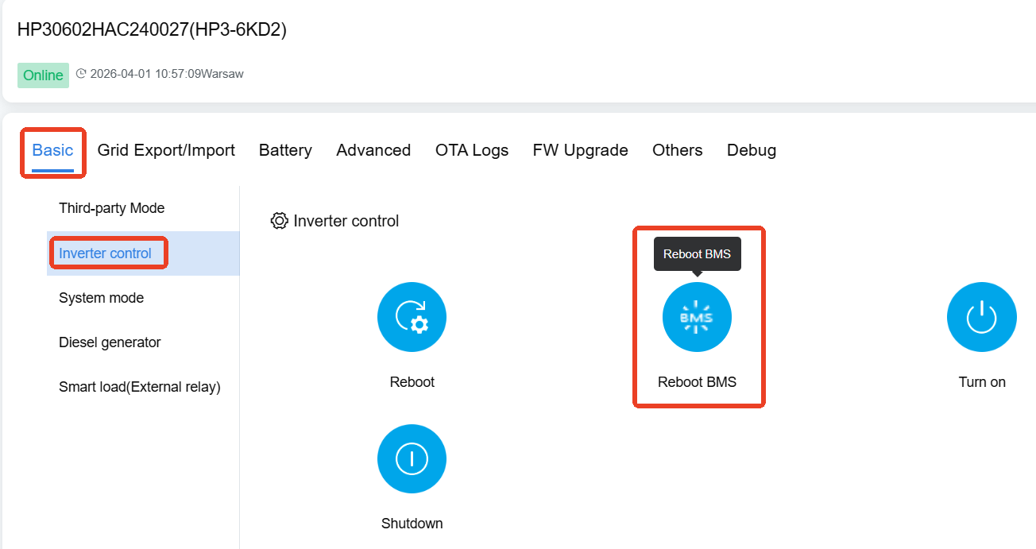  As shown in the figure, click the button to remotely restart the BMS;
Step8 | If the MOS remains disconnected after the battery is remotely restarted, please contact the end user or installer of the site to manually restart (open and close) the high voltage battery air switch.  If the inverter can read the total battery voltage after manually restarting the open, jump to Step5;  If the inverter still cannot read the total battery voltage after manually restarting the open, please contact the local after-sales service team. | 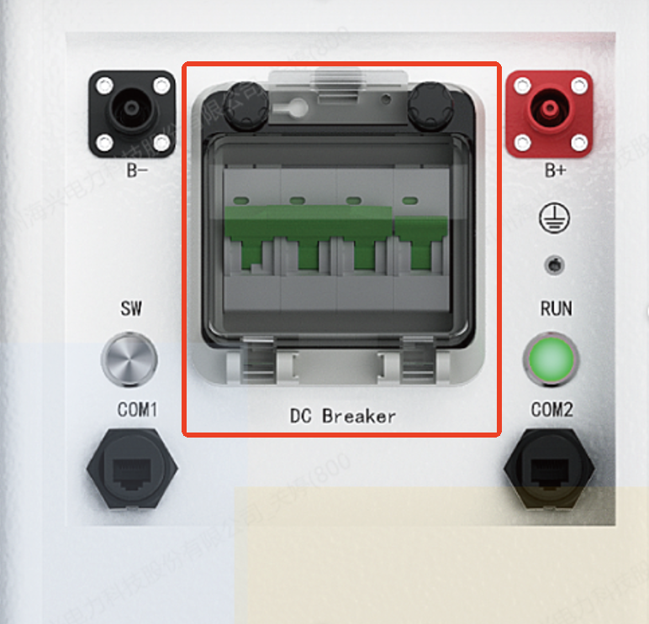  As shown in the figure, it is necessary to manually restart the BMS air switch of the high-voltage battery;

