HYPER-5000 Mixed Upgrade Causing Parallel Processing SOP

- Fault Name:Firmware version mismatch
- Fault code:F2 00004000
- Fault phenomenon:After upgrading the firmware, the "Firmware Version Mismatch" alarm will be prompted, and the fault alarm will still exist after dropping back to the original version
- Cause of failure:Upgrade DSP firmware chaotically-Upgrade to V3 parallel firmware, set up parallel in the monitoring platform, upgrade the firmware to V4 stand-alone firmware, and then fall back to V3 parallel firmware, resulting in this alarm, and the actual parallel cannot be done.
- Applicable models:HYPER-5000
- Troubleshooting steps:
procedure | Contents | Example (picture or reference file)
Step1 | Log in to the monitoring platform, select Setting-Firmware Upgrade, and downgrade the DSP1 and DSP2 Firmware back to version V3.0.0; | 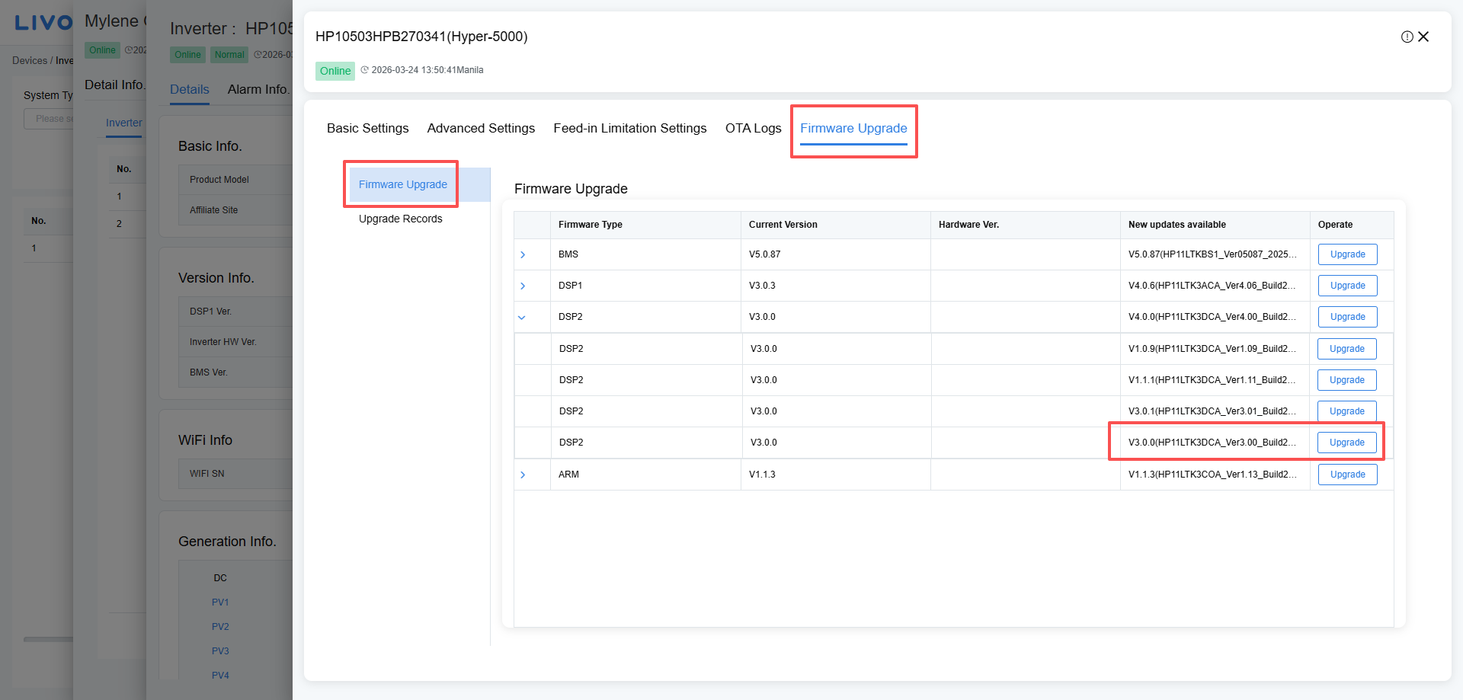
Step2 | Turn off the battery, power grid and PV, and change the on-site wiring to single-machine wiring after completely disconnecting the system;
Step3 | Turn on the battery, grid, PV and power up the system.  If the system can work normally in the stand-alone state, continue to STEP 4;  If it does not work properly, contact the local after-sales service team to handle it.
Step4 | Contact the local after-sales service team and send a factory reset instruction to the faulty inverter;  After restoring the factory settings, turn off the battery, power grid and PV, and change the on-site wiring back to parallel wiring after the system is completely powered off;  Re-turn the battery, power grid and PV, and after the system is powered on, select Setting-Advanced Settings-Installation Setup on the monitoring platform, enable Parallel connection and set the master and slave machines, set the master ID to 1 and the slave ID to 2, and save the Settings; | 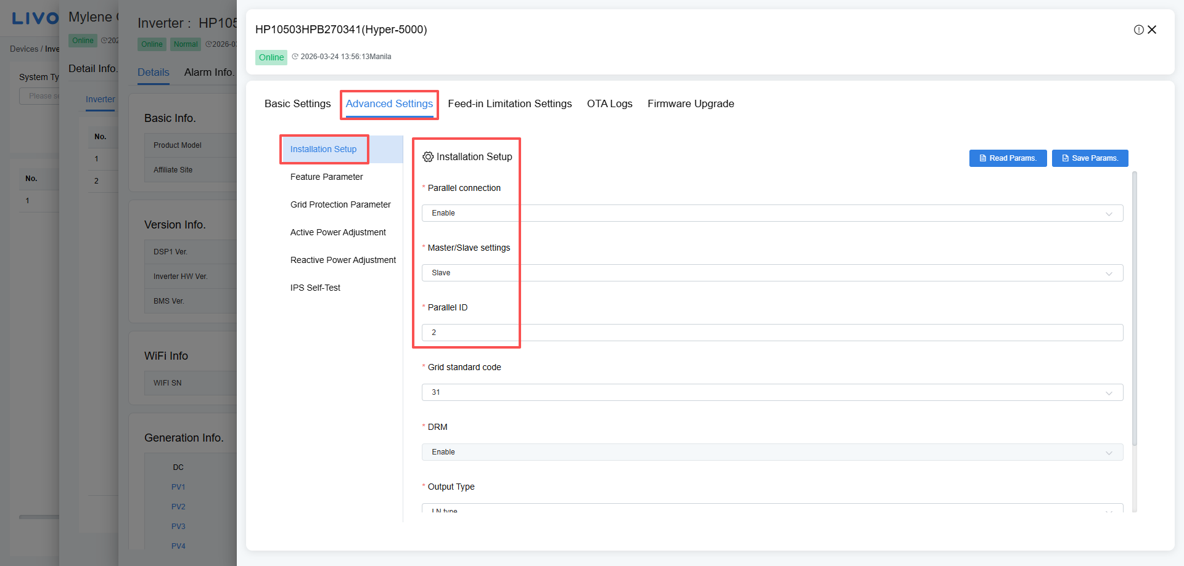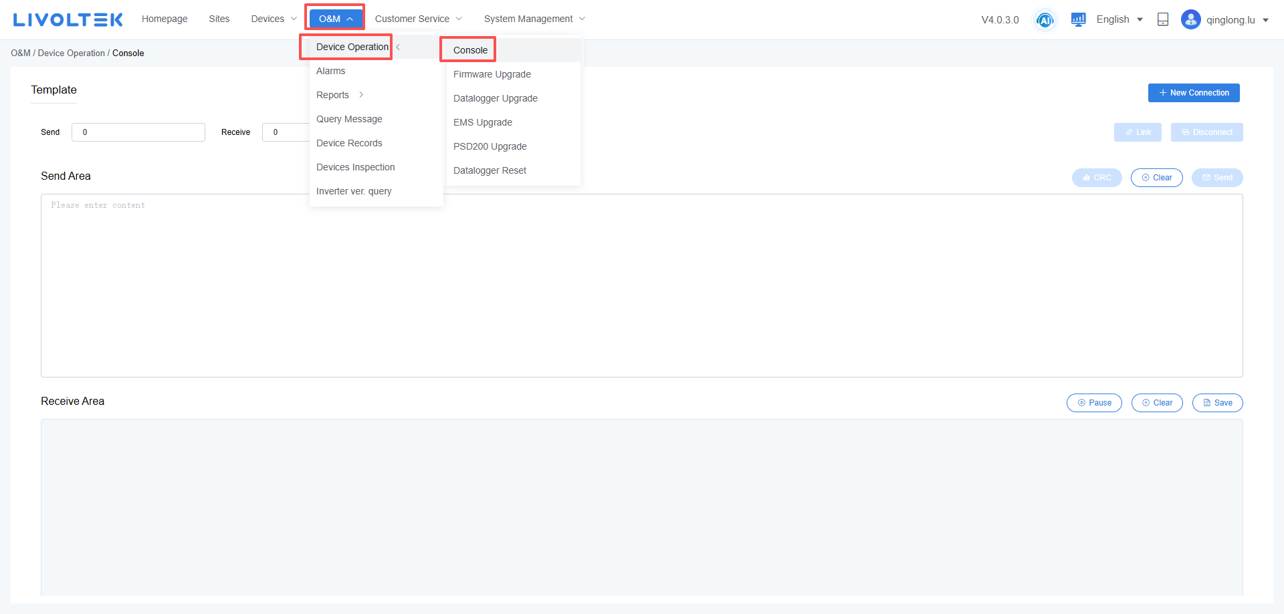
Step5 | Restart the inverter and wait 2~3 minutes.  If the inverter is working normally, the fault is resolved.  If the inverter is still faulty, contact the local after-sales service team to handle it.

