Inverter Cannot be connected to Monitoring Platform Processing SOP

- Fault Name:The inverter cannot be connected to the monitoring platform
- Fault code:None yet
- Fault phenomenon:On the monitoring platform or APP, the communication status of the inverter continues to display offline.
- Cause of failure:
- Poor contact of WiFi stick with inverter terminal
- WiFi Stick Unconfigured Network
- WiFi Stick Version Too Low
- Customer Field Router Signal Unstable
- Wrong selection of WiFi stick domain name
- WiFi Stick Damaged
- Inverter terminal damaged
- Applicable models:All models
- Troubleshooting steps:
procedure | Contents | Example (picture or reference file)
Step1 | Check that the WiFi stick is tightly plugged in and in good contact with the inverter terminals.  If the contact is bad, please unplug the WiFi stick and replug it; If normal, refer to Step2;
Step2 | Verify if the WiFi stick has completed network distribution.  If the network is not allocated, please re-allocate the network through the monitoring platform or APP. Please refer to Attachment 1 for the specific network allocation steps:PSD300-WiNet Setting Guideline_25.07.25。  If the network has been distributed, refer to Step3;
Step3 | Check if the WiFi Stick Server domain name selection is correct.  The correct server domain name should be:  Asian clothes: https: / /aa.livoltek-portal.com; Europe: https: / /evs.livoltek-portal.com;  International service: https: / /www.livoltek-portal.com;  If the domain name is wrong, please select the correct domain name; If correct, refer to Step4; | 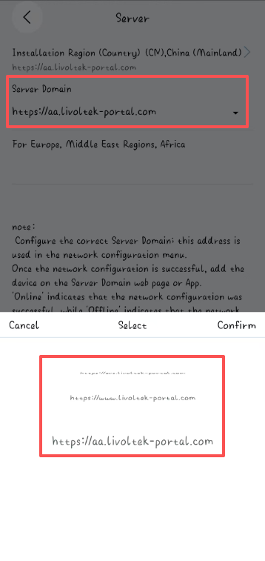
Step4 | Check if the WiFi stick version is the latest version (if there is a latest version but it is not updated, this option will have an update icon).  If the version is too low, upgrade the WiFi stick locally. If the version is the latest version, refer to Step5; | 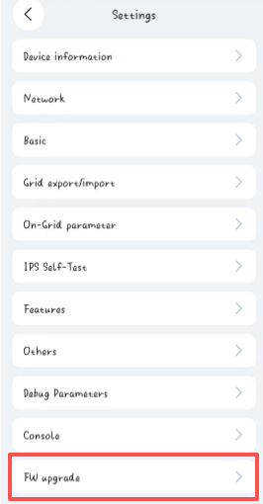
Step5 | Use a mobile phone hotspot to distribute the WiFi stick.  If the network distribution is successful, it means that the original WiFi signal is weak or unstable. Please approach the router or change the network environment;  If the distribution network fails, refer to Step6;
Step6 | Please replace the WiFi stick.  If the distribution network is successful after replacing the WiFi stick, the problem is solved; If the distribution network still fails after replacing the WiFi stick, please contact your local after-sales service team for assistance.

Annex 1：PSD300-WiNet Setting Guideline_25.07.25

