Single-phase Storage Inverter 5KW Rework File

I. Background and purpose of the problem
Main reason: the contact between the light panel wire and the inductor wire leads to a white screen; It needs to be restructured and reworked;

Reworked products
HP1-5KS2R11003The specific number of overseas factories shall prevail;

3. Materials required for rework:
3070500080 4*250 single machine cable tie 1 piece (quantity of 1 piece per unit)

Four,Rework scheme
1. Remove the packaging and pay attention to the reuse of packaging accessories;
2. Remove the cover: (6 screws removed by 2N.m torque are reused)
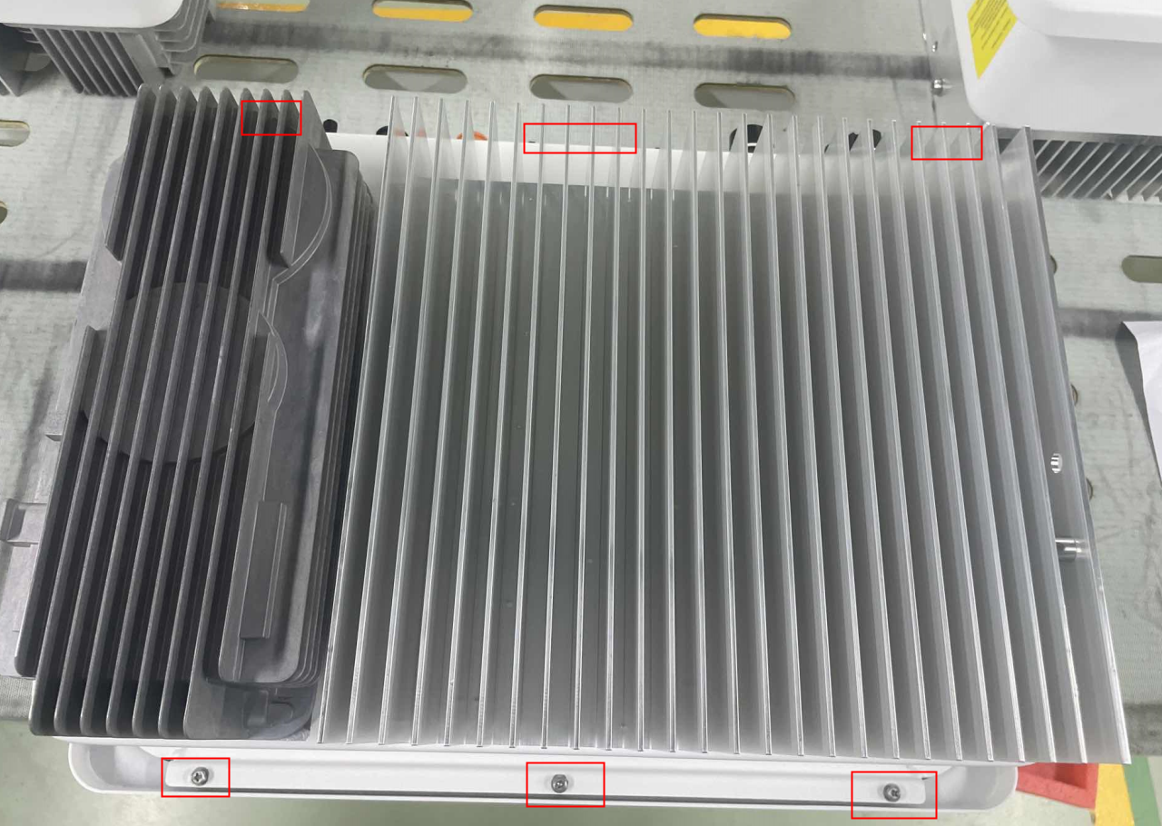
Figure 1
3. Cable rework: as shown below
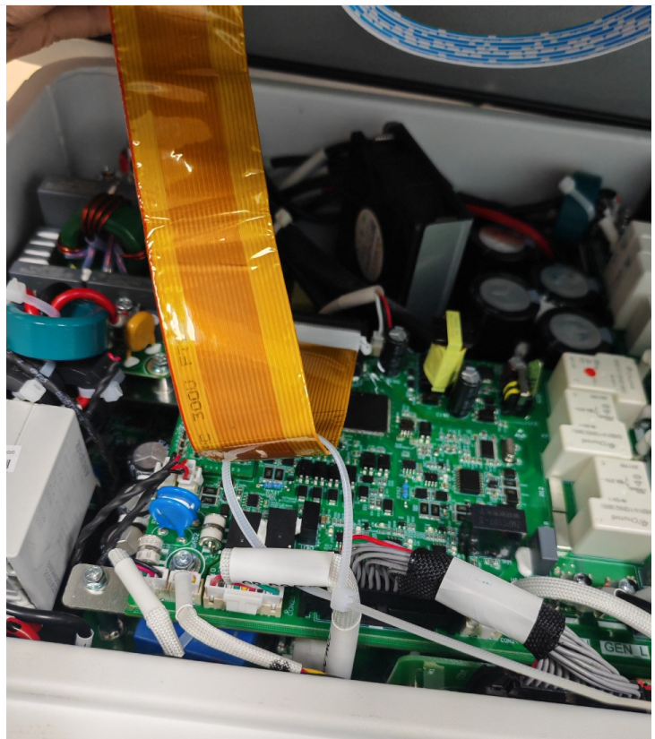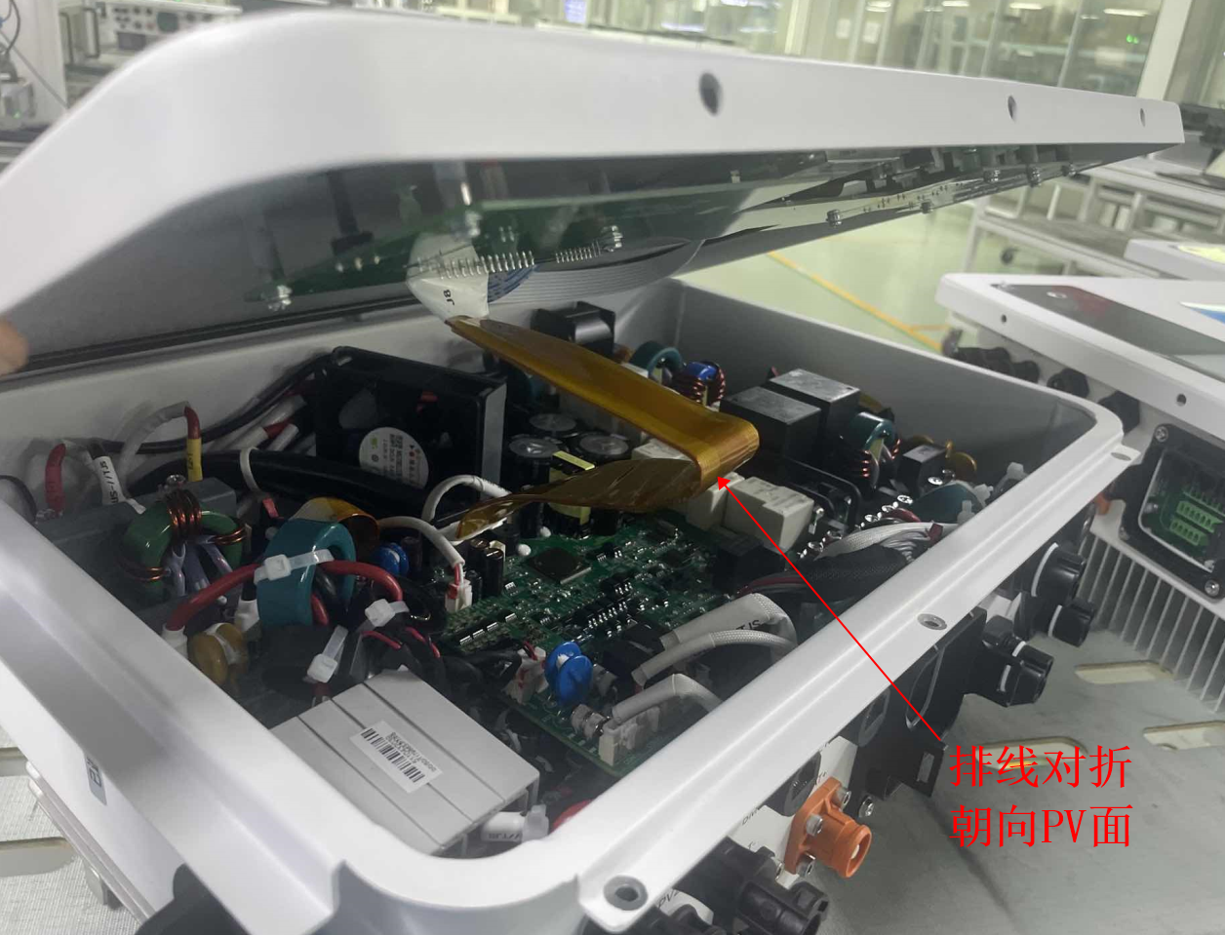
Figure 2Figure 3

As shown in Figures 2 and 3: the cable from the lamp panel to the OB is folded in half toward the PV face end to avoid communication interference; Fold the cable in half towards the PV face end, and tie a cable tie to fix it; (Note: The cable tape can't be completely stuck, so there should be a margin. According to the tightness of Figure 2, fix the cable);
4. Fixing the upper cover: fixing screw sequence: diagonal fixing screw;(Removed screw fixed, torque: 1.7-1.9N.m)
5. Power-on test: Power on for 3 minutes to check whether there is any abnormality on the screen;
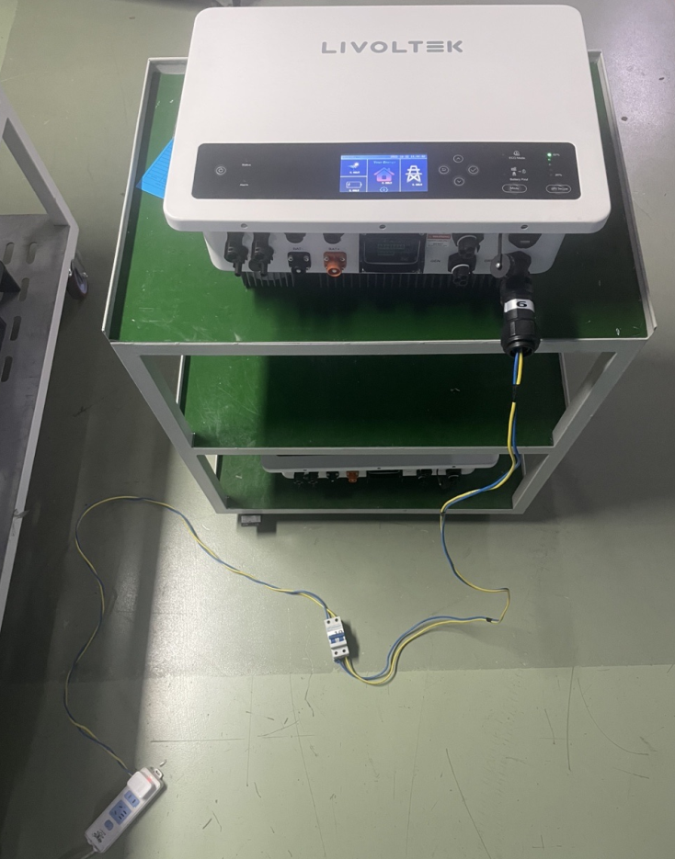
Figure 4
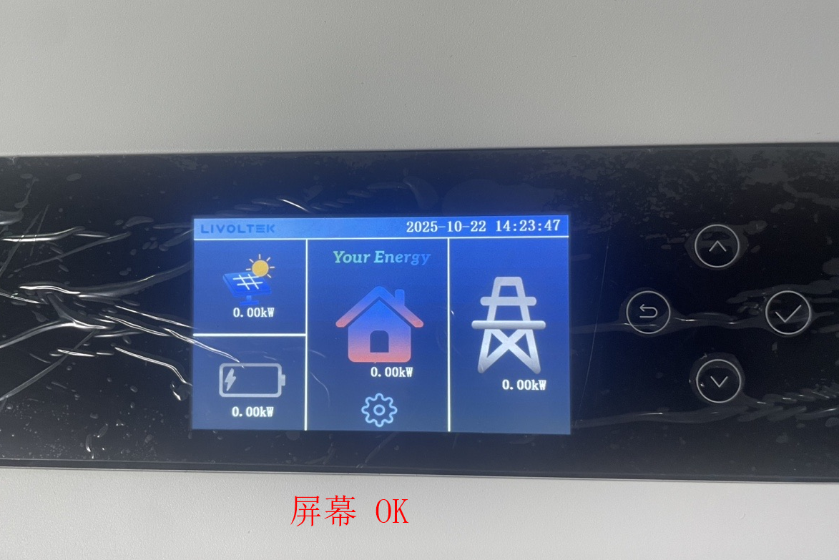
Figure 5 (Screen Normal Condition)
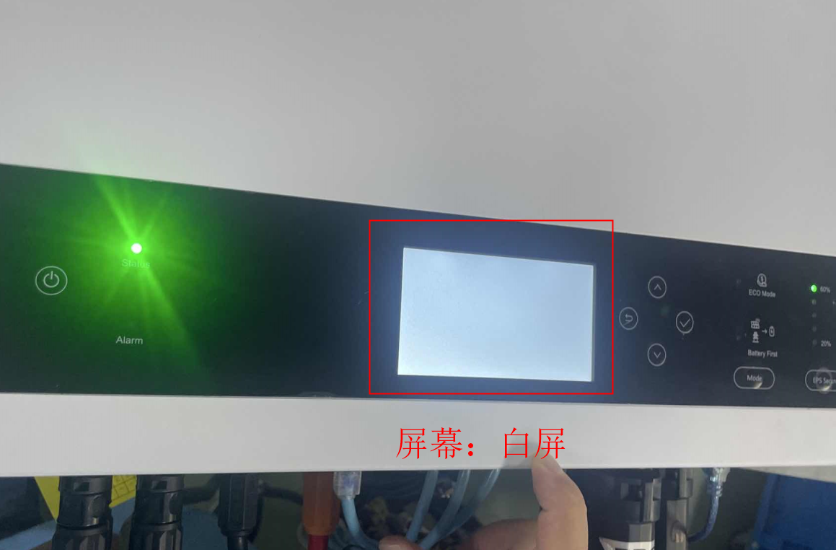
Figure 6 (Screen Abnormal Condition)
6. The packaging is carried out according to the original (removed) packaging; (The SN number of the removed machine should correspond to the package)
7. Process flow: power-on test + packaging inspection;

Remarks:
1. There is no airtight test instrument in overseas factories, and the torque must be 1.7-1.9N.m (six screws on the cover plate)
2. Pay attention to unpacking: the packaging box cannot be damaged;
3. When packaging, pay attention to the fact that the packaging accessories cannot be missing and missing:
Prepared by: Cheng Baolei Approved by: Meeting decision

