Low-volt Battery Cell Over-voltage Protection Treatment SOP

- Fault Name:Battery cell overvoltage protection
- Fault code:BA3 0002
- Fault phenomenon:The battery light bar of the inverter LCD screen is disconnected, and the circle in the middle lights red
- Cause of failure:Single cell overvoltage of battery
- Applicable models:BLF 51-5
- Troubleshooting steps:
procedure | Contents | Example (picture or reference file)
Step1 | View the firmware version of the battery on the monitoring platform.  If the BMS version of the battery is not V5.0.88, jump to Step2;  If the BMS version of the battery is V5.0.88, jump to Step3;
Step2 | Upgrade the firmware of the BMS to V5.0.88 and observe if the fault is eliminated and the battery works properly.  If the fault is eliminated and the battery is working properly, the problem is resolved.  If the fault is not eliminated, or the battery still does not work properly, jump to Step3;
Step3 | View the maximum cell Voltage information (Max Pack Voltage) of the battery at the time of error on the monitoring platform.  If the cell voltage exceeds 3.6V, jump to Step5;  If the cell voltage does not exceed 3.6V, jump to Step4; | 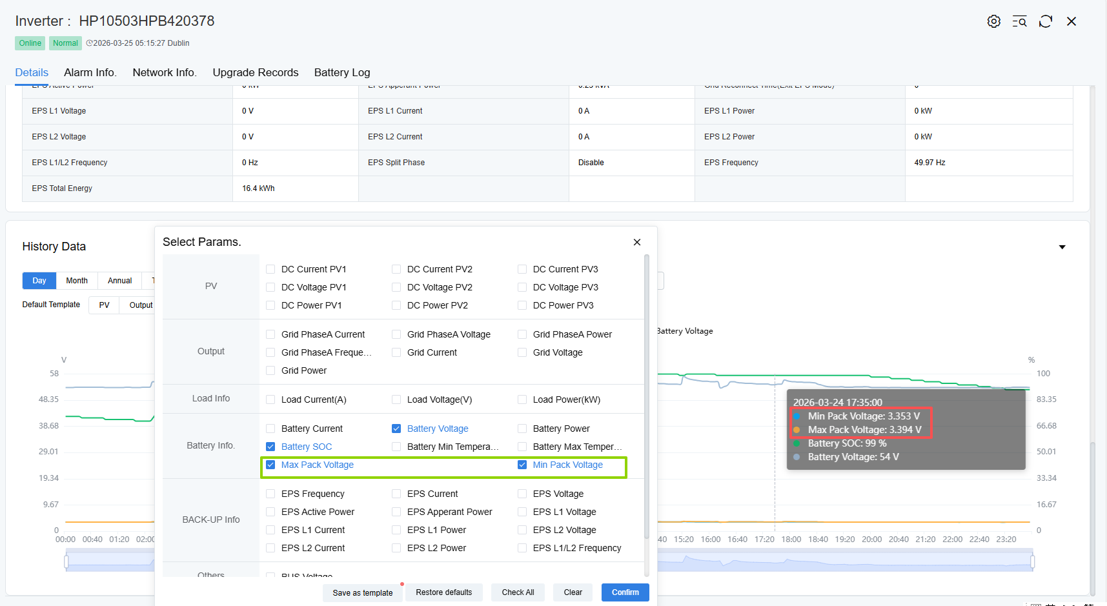
Step4 | Remotely restart the BMS and manually restart the battery DC open to observe whether the fault is eliminated.  If the fault is eliminated, the problem is resolved.  If the failure is not eliminated, jump to Step5;
Step5 | Contact the local after-sales service team to provide measurement videos and pictures for after-sales remote assistance in troubleshooting or machine replacement.

