Low-volt Battery Cell’s Large Voltage Difference Protection Treatment SOP

- Fault Name:Large voltage difference of low-voltage battery cell
- Fault code:None yet
- Fault phenomenon:
- Too fast battery charge and discharge is accompanied by SoC jump
- Reduced battery capacity, reduced discharge
- Cause of failure:
- Mixed use of new and old batteries
- Applicable models:BLF 51-5
- Troubleshooting steps:
procedure | Contents | Example (picture or reference file)
Step1 | Check the maximum Pack Voltage (Max Pack Voltage) and the minimum Pack Voltage (Min Pack Voltage) through the monitoring platform for difference judgment.  When the cell voltage difference is above 500mV and the equipment reports the alarm of "cell overvoltage protection", please refer to Step2;  When the cell voltage differential is below 500mV, please contact the local after-sales service team. | 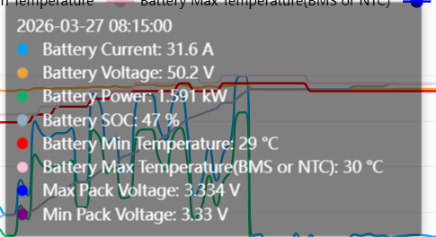
Step2 | If there is only one battery, please check whether the maximum and minimum cell voltage difference of the battery is above 500mV on the platform, and contact the local after-sales service team.  If multiple batteries are connected in parallel, please refer to Step3;
Step3 | Disconnect the parallel connection between the batteries, connect one battery separately to the inverter, and check whether the maximum and minimum cell voltage difference is above 500mV on the platform at this time. Repeat this operation and check the maximum and minimum cell voltage difference of all battery packs.  If the maximum and minimum cell voltage difference of the battery pack is above 500mV, please contact the local after-sales service team.  If all are below 500mV, please refer to Step4;
Step4 | Change the inverter mode to a backup mode or user-defined mode to fully charge the battery and repeat until all battery packs are fully charged to 100%.

