Low-volt Battery Overvoltage Alarm Handling SOP

- Fault Name:Battery overvoltage alarm
- Fault code:577
- Fault phenomenon:The inverter indicator light and the battery indicator light red
- Cause of failure:
- Battery cell overvoltage
- Firmware version is too low
- Applicable models:HYPER-3 to 6kW, BLF 51-5;
- Troubleshooting steps:
procedure | Contents | Example (picture or reference file)
Step1 | View the firmware version of the battery on the monitoring platform.  If the BMS version of the battery is not V5.0.88, refer to Step2;  If the BMS version of the battery is V5.0.88, refer to Step3;
Step2 | After upgrading the firmware, observe if the fault is eliminated and the battery is working properly.  If it still does not work properly, refer to Step3;
Step3 | On the monitoring platform, check the maximum cell voltage of the battery according to the error reporting time (Max cell BAT Volt).  If the single cell voltage does not exceed 3.6V, refer to Step4;  If the single cell voltage exceeds 3.6V, refer to Step5; | 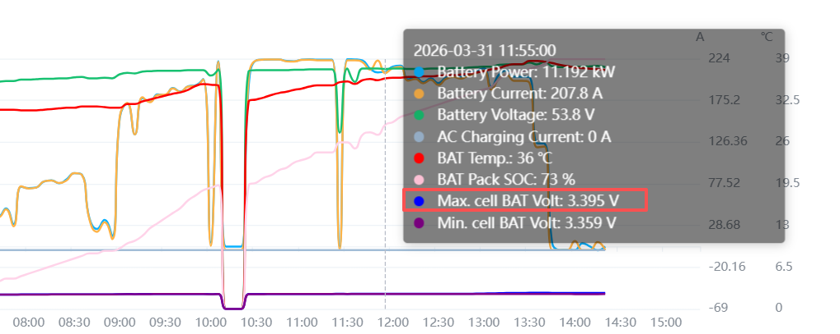
Step4 | Remotely restart the BMS and manually restart the battery DC open to observe whether the fault is eliminated.  If the fault is not eliminated, refer to Step5; | 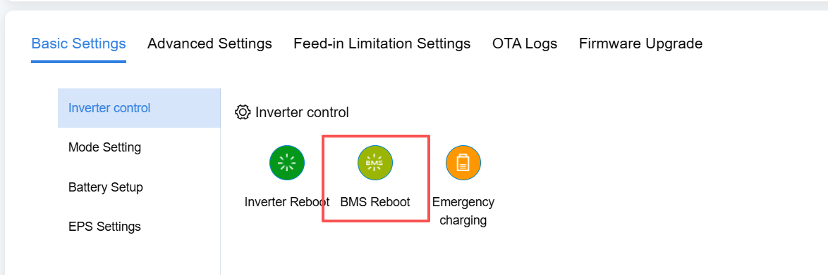
Step5 | Manually set the battery charge ceiling, lowering the charge ceiling to 98%;  If it is still unresolved, please contact your local after-sales service team. | 