Low-volt Battery with Zero Min.Cell Volt Processing SOP

- Fault Name:LOW SOC; LOW BAT Voltage
- Fault code:None yet
- Fault phenomenon: The battery cannot be charged, and the monitoring platform shows that the min cell voltage is 0
- Cause of failure:Communication with the inverter or problems with the battery itself
- Applicable models:BLF51-5 battery, off-grid machine, single-phase hybrid inverse full power segment
- Troubleshooting steps:
procedure | Contents | Example (picture or reference file)
Step1 | Through the monitoring platform, the minimum voltage of the battery cell is 0, and an error is generated, so the battery cannot be charged
Step2 | Give priority to on-site inspection of the BMS communication line to confirm whether there is a fault in the cable or port, such as damaged cable or excessive dust in the port, which affects the communication. If the communication is normal, it enters the third step, and if the communication is abnormal, a new cable will be made to ensure that the port contact is good.
Step3 | When the communication is good, it is judged that there is a problem with the battery itself, a software problem or a hardware problem | 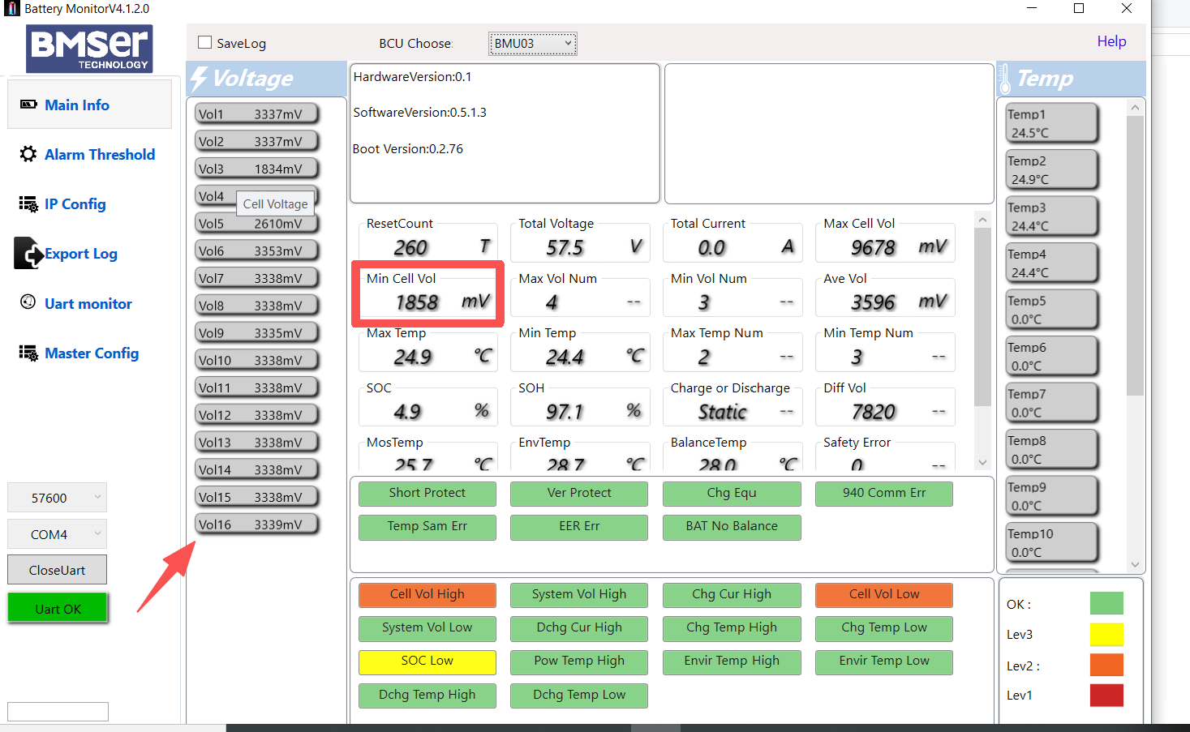
Step4 | Try the host computer to read the battery information and verify whether the single voltage of a certain battery cell is 0. If it can actually read that a certain battery cell is 0, it is judged that the battery cell has starved to death, and the battery is replaced
Step5 | If the cell voltage is normal, use single-phase mixed inverter, off-grid machine, no communication or communication to forcibly charge (emergency, or activation)
Step6 | DC source, or strong charging by charger
Step7 | The host computer forcibly closes the MOS to forcibly charge. If the current is charged in a certain method, it can be upgraded to the latest firmware to ensure that the subsequent system runs normally

