Low-volt Battery’s SoC Low Protection Treatment SOP

- Fault Name:Low voltage battery SoC is too low
- Fault code:None yet
- Fault phenomenon:
- The machine reports that the battery voltage is too low
- Abnormal battery failure
- Cause of failure:
- BMS firmware version is too low
- Not fully charging the battery to 100% for a long time
- Failure to regularly recharge the battery
- Applicable models:BLF51-5
- Troubleshooting steps:
procedure | Contents | Example (picture or reference file)
Step1 | Check whether the BMS is the latest version on the monitoring platform, and if not, upgrade to the latest version.  If it is already the latest version, jump to Step2;
Step2 | Check the battery SOC and cell voltage on the monitoring platform:  If it is found that the battery SOC is below 10% for a long time and the single cell voltage is less than 3V but greater than 2.5, jump to Step3;  If the single cell voltage is less than 2.5V, jump to Step4; | 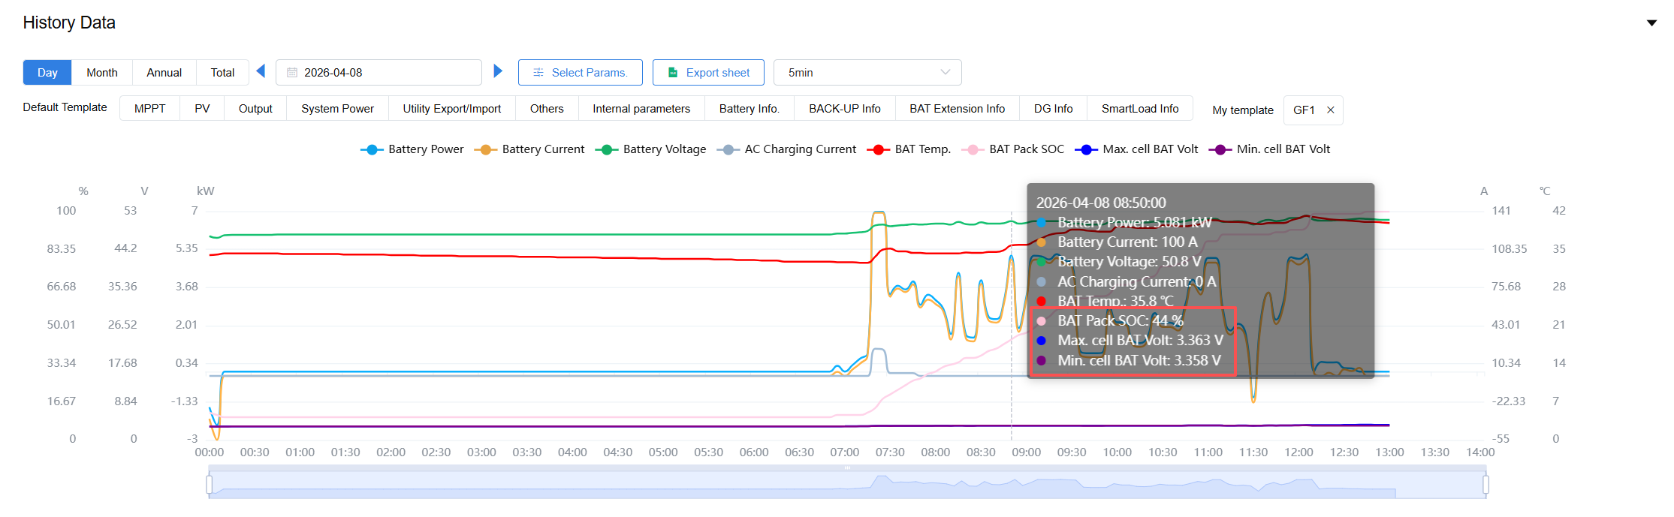
Step3 | Manually set the inverter mode to either backup mode or TOU mode to fully charge the battery to 100%. | 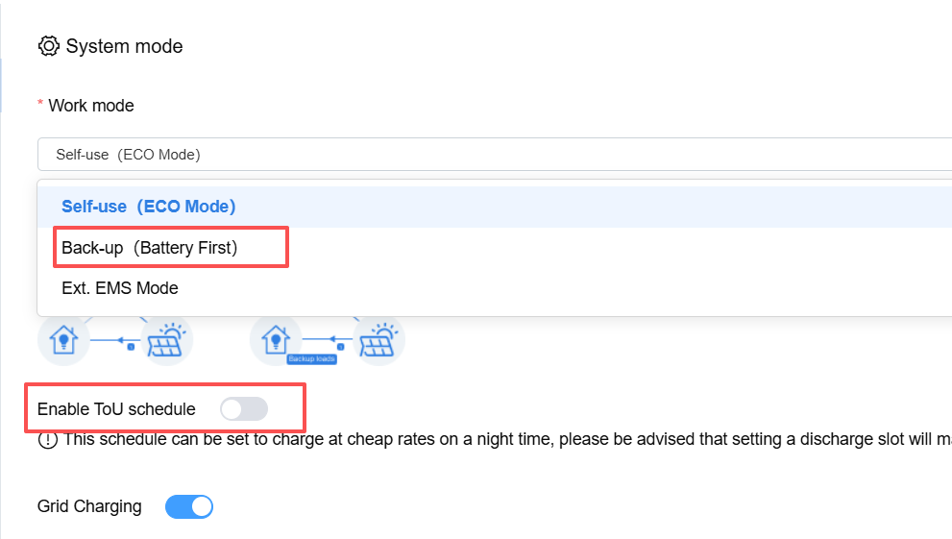
Step4 | Refer to attached documentation:New model DC charger operation SOP，Recharge the battery.  If the battery SoC value is still very low after replenishment, please contact your local after-sales service team.

