Overload Protection Alarm Handling SOP

- Fault Name:Off-Grid Load Overpower Fault
- Fault code:112
- Fault phenomenon:The BACK-UP port of the inverter stops output, and the FAULT indicator flashes red on the LCD screen of the inverter
- Cause of failure:
- Inverter BACK-UP Port Single Phase Line Connects Too Much Load Exceeding Maximum Load Limit
- The sum of the three-phase line load of the inverter BACK-UP port exceeds the maximum limit of the inverter
- The inverter is connected to an inductive load, which is instantaneously overloaded when the inductive load is started
- Applicable models:
- HP3-5~12kW D2
- HP3-15~30kW T2
- Troubleshooting steps:
procedure | Contents | Example (picture or reference file)
Step1 | View the inverter historical data on the monitoring platform, check the parameter "BACK-UP Power", and observe whether the sum of the three-phase loads exceeds the maximum limit of the inverter (1.1 times the rated Power of the inverter).  If the maximum limit is exceeded, please refer to Step2;  If the maximum limit is not exceeded, please refer to Step3; | 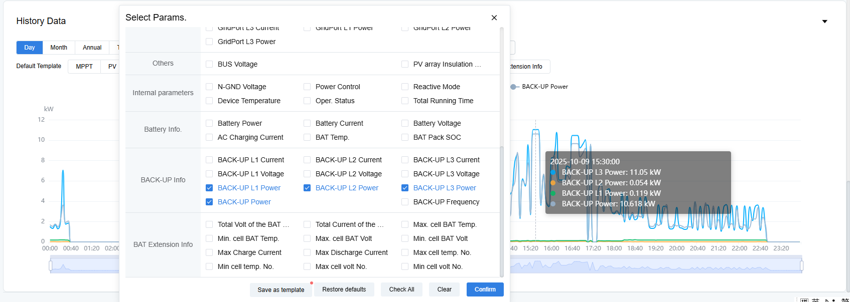
Step2 | Schedule all loads for peak shifting use (i.e. do not turn on all loads at the same time) to limit the total load power to the maximum range.  If peak shifting is supported, this problem is solved.  If peak shifting is not supported, please refer to Step8;
Step3 | View the inverter history data on the monitoring platform, check the parameters "BACK-UP L1 Power", "BACK-UP L2 Power", "BACK-UP L3 Power", Observe if the single phase load exceeds the maximum limit of single phase. (The maximum single-phase support of HP3-5~12kW model is 4.4kW, and the maximum single-phase support of HP3-15~30kW model is 11kW);  If the maximum limit is exceeded, please refer to Step4;  If the maximum limit is not exceeded, please refer to Step7;
Step4 | Schedule overloaded phase loads for peak shifting use (i.e. do not turn on all loads at the same time), and limit the total power of the load to the maximum range of single phase.  If peak shifting is supported, this problem is solved.  If peak shifting is not supported, please refer to Step5;
Step5 | If the single-phase load is too large, exceeding or approaching exceeding the maximum limit, but the other phase loads are small, please refer to Step6;  If the single-phase load is too large, exceeding or approaching exceeding the maximum limit, and other phase loads are also relatively large, please refer to Step8;  If the three-phase loads are all relatively balanced and all are less than the maximum limit, please refer to Step7;
Step6 | Disconnect all loads, properly connect the load with more phases of load to the phase with less load, restart the load, and observe if the overload alarm is eliminated.  If the alarm is eliminated, the problem is resolved.  If the alarm is not eliminated. Please refer to Step7;
Step7 | Explain that the overload alarm may be instantaneous overload caused by the start of inductive load. Observe whether some motor or pump loads, such as cutting machine and water pump, are connected to the system.  If it is confirmed that an inductive load is connected, refer to Step 8;
Step8 | Please contact the local after-sales service team to handle it.

