PE Line Fault Handling SOP

- Fault Name:PE Abnormal
- Fault code:23
- Fault phenomenon:"Ground fault" alarm is reported during the operation of the inverter, and the inverter is shut down and cannot work normally
- Cause of failure:
- Ground wire not connected;
- The zero (N) line-to-ground voltage is too high because of line aging or poor insulation;
- The "output mode" of the equipment is inconsistent with the actual wiring mode;
- Applicable models:All models
- Troubleshooting steps:
procedure | Contents | Example (picture or reference file)
Step1 | Log in to the monitoring platform to check whether the Output Type is consistent with the actual wiring. If they agree, refer to step2; If it is inconsistent, modify it to the correct Output Type according to the local wiring standard. | 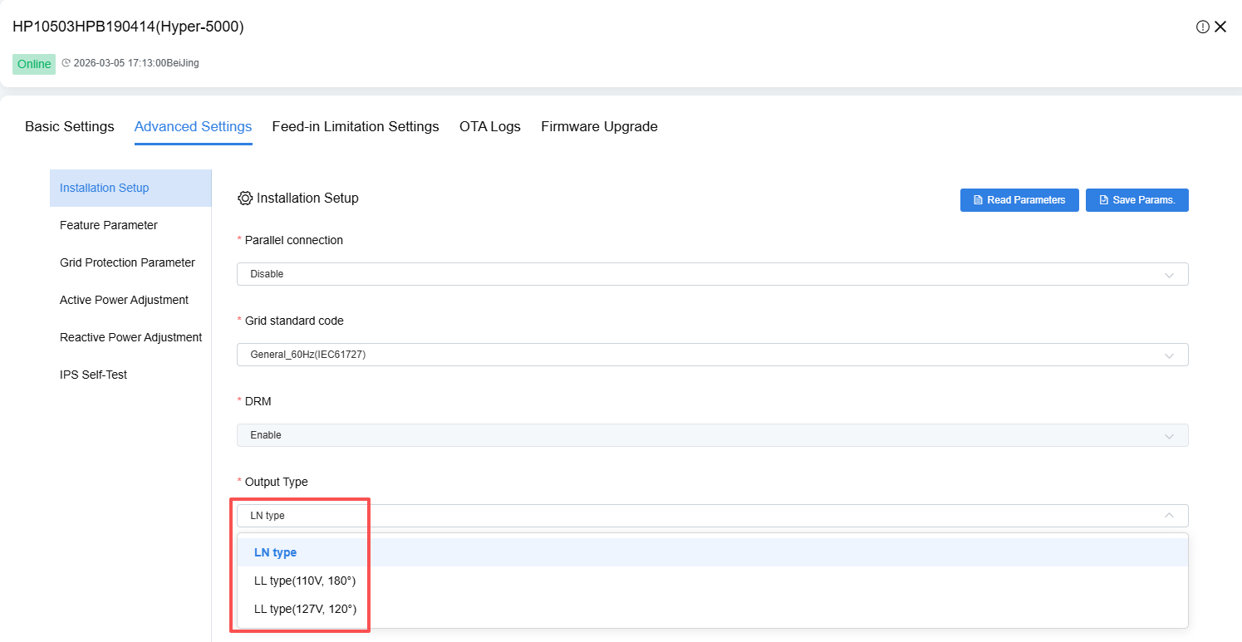
Step2 | On-site power outage：  Close the AC side opening and turn the DC PV knob to OFF gear to completely cut OFF the power supply;
Step3 | Use a multimeter to confirm that there is no voltage between the mains port and the PV terminal of the equipment. If there is voltage, check the open and knob again. If there is no voltage, refer to step4;
Step4 | Check that the ground wire is connected correctly and firmly, and if not, connect correctly (refer to Annex 1 for details:Quick Installation Guide_Hybrid Inverter_V2408.pdf), if connected and secure, continueMeasure the ground resistance and confirm whether it is less than or equal to 4 Ω;  Check AC/DC cable insulation to verify no damage or moisture.  If the wiring is weak, the cable is damaged and damp, and the resistance is greater than 10 ohms, repair and replace the grounding cable. If it does not exist, refer to step5.
Step5 | If the grounding fault continues to be reported after troubleshooting, you can disable the grounding fault detection in the monitoring platform settings and observe whether the alarm is eliminated. If eliminated, refer to step6; If not eliminated, refer to step7; | 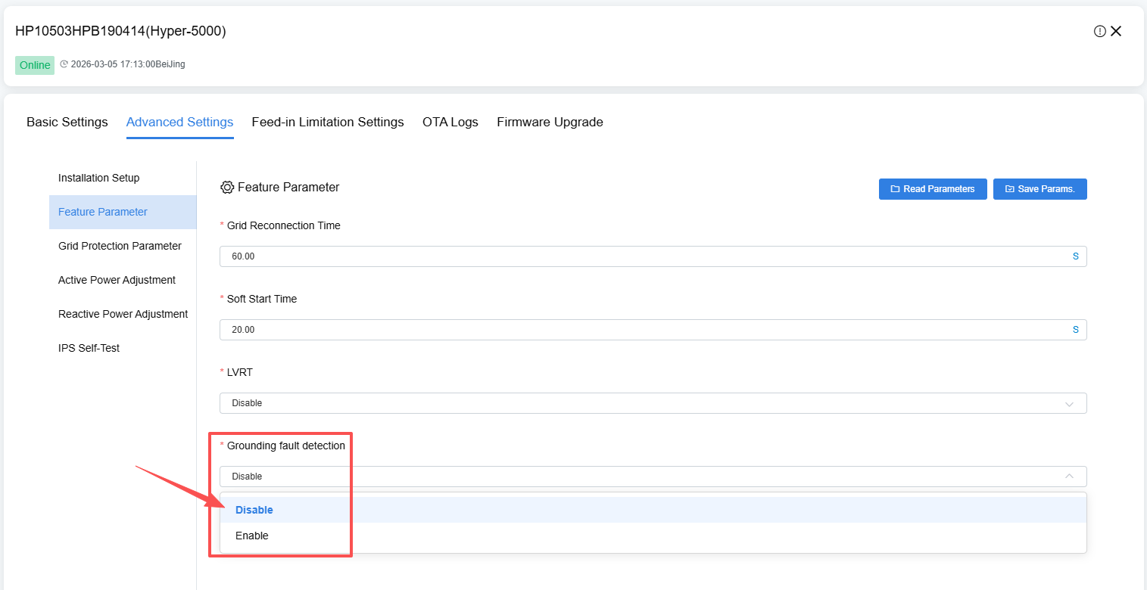
Step6 | Restart the device and verify that the running state has returned to normal. If it returns to normal, the problem is solved; if it does not return to normal, refer to step7;
Step7 | If the above steps still do not solve the problem, please contact your local after-sales service team.
Attachment 1:Quick Installation Guide_Hybrid Inverter_V2408.pdf

